Report For Lab 8

Connor McCullough
EEN 312
17 April 2013

Objective:
Explore the debugging features for a program in assembly using Visual Studio 2008 or 2010. This including the step feature, the breakpoint feature, and looking at the values of individual registers and how they change from step to step.

Equipment:
Windows Visual Studio 2010, step debugger, breakpoints, registers

Results:
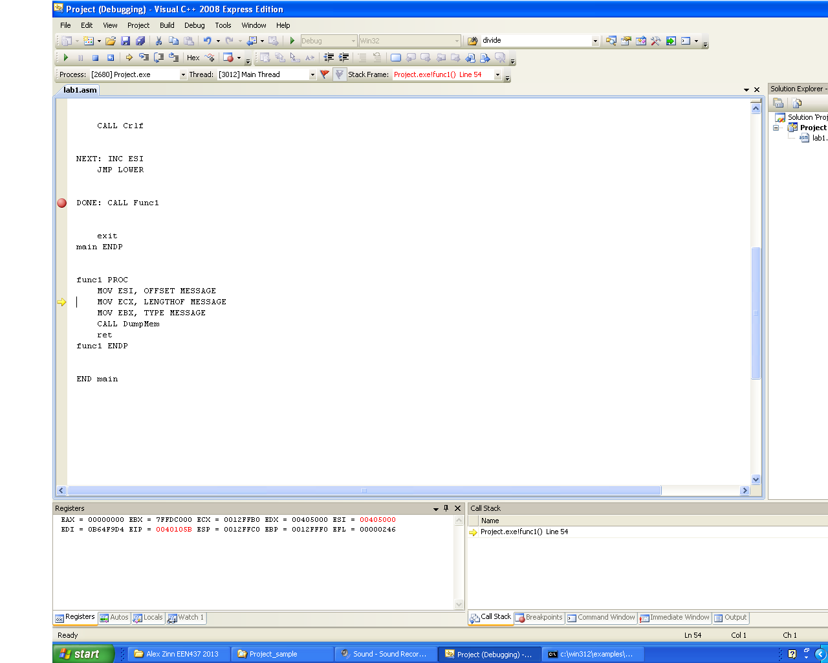

Program during Part B

Question 1: The size of the ADD AL, Range instruction based on the EIP register change is 2 bytes

Question 2: The offset value of MESSAGE is 00405000

Conclusion: This lab showed the use of Visual Studio to debug an assembly program. Being able to look at the values of individual registers and how they change over time is very useful in debugging because you know what is happening from step to step. Being able to place breakpoints is useful when there is one particular step you want to look at, but don’t want to step through the entire program.

Code:
TITLE lab1.asm

COMMENT *
DESCRIPTION: THIS PROGRAM CONVERTS A STRING OF
CHARACTERS FROM UPPER CASE TO LOWER CASE.
A 0 IS USED TO DENOTE THE END OF THE STRING.
*
INCLUDE Irvine32.inc

BLANK EQU 20H
RANGE EQU 32

.data
MESSAGE DB 'MUMBO JUMBO', 0

.stack 100h

.code
main PROC
CALL CLrscr
MOV ESI, OFFSET MESSAGE

LOWER: MOV AL, [ESI]
CMP AL, 0
JZ DONE
CMP AL, BLANK
JZ NEXT
ADD AL, RANGE
MOV [ESI], AL
MOV EDX, OFFSET MESSAGE
CALL WriteString

CALL Crlf

NEXT: INC ESI
JMP LOWER

DONE: CALL Func1

exit
main ENDP

func1 PROC
MOV ESI, OFFSET MESSAGE
MOV ECX, LENGTHOF MESSAGE
MOV EBX, TYPE MESSAGE
CALL DumpMem
ret
func1 ENDP

END main

