Report For Lab 7

Connor McCullough
EEN 312
3 April 2013

Objective:
Write a program that converts a signal from Analog to Digital and processes input signal according to several piecewise linear functions. Afterwards, the signal will be converted back from digital to analog.

Equipment:
- Text editor and 8051 ASM assembler
- Step debugger to execute program one instruction at a time
- Data memory, accumulator, code memory
- Keyboard panel, Text monitor panel

Results:
Output at 0V is 5V:
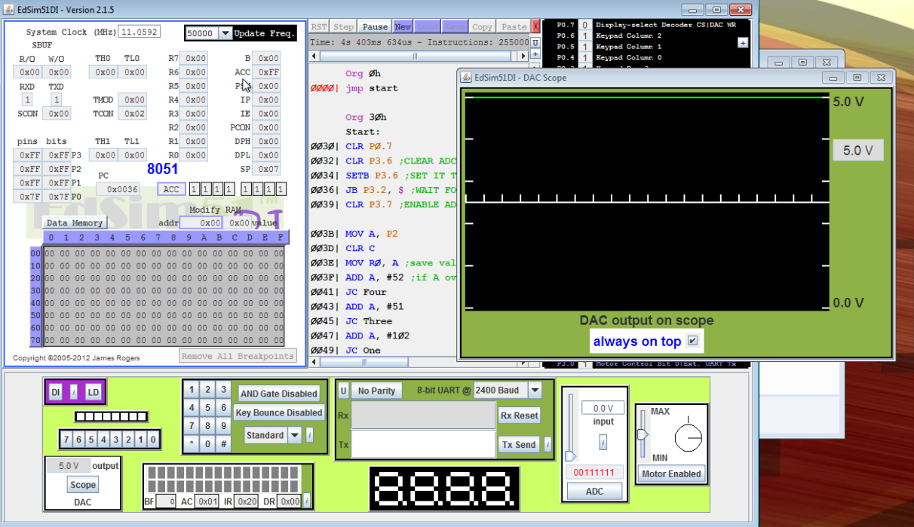

Output at 1V is 1V:
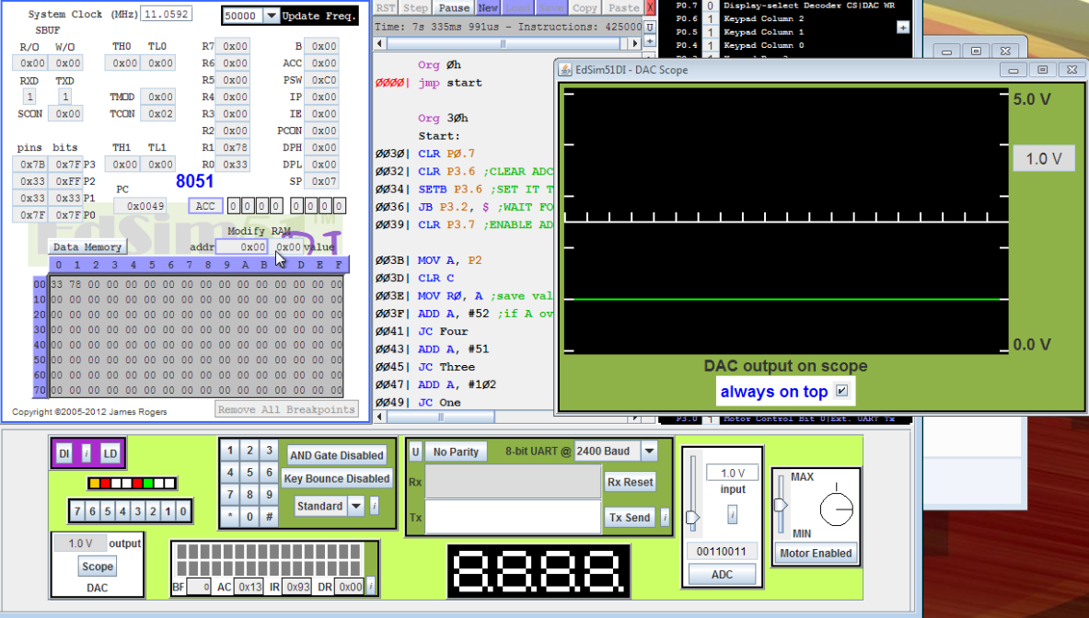

Output at 2V is 1V:
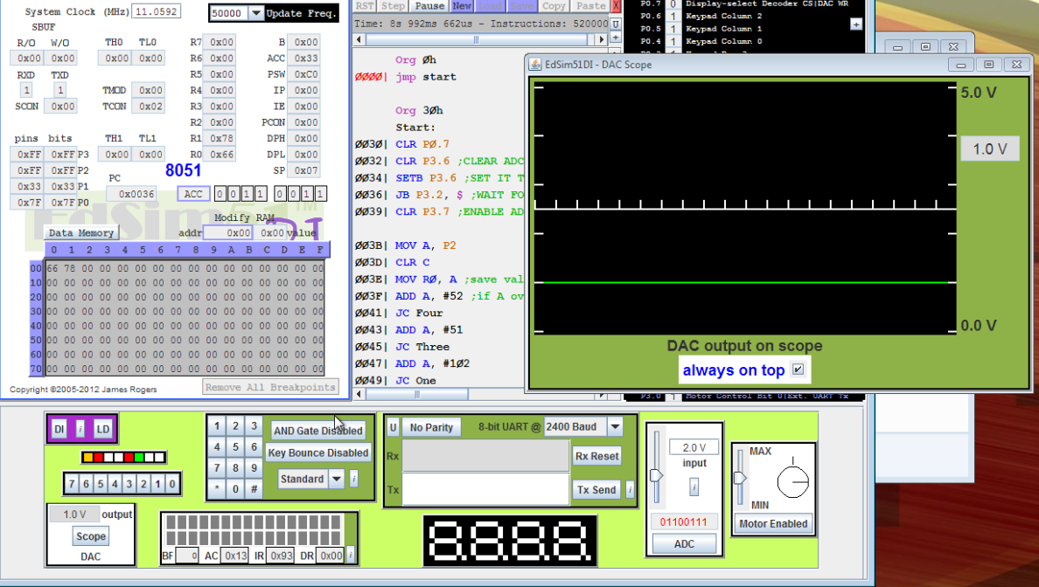

Output at 3V is 1V:
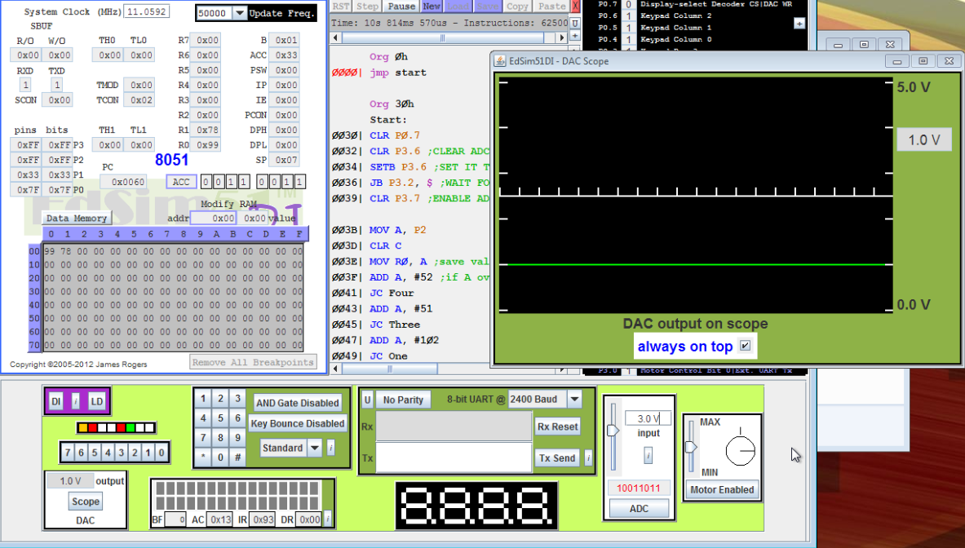

Output at 4V is 4V:
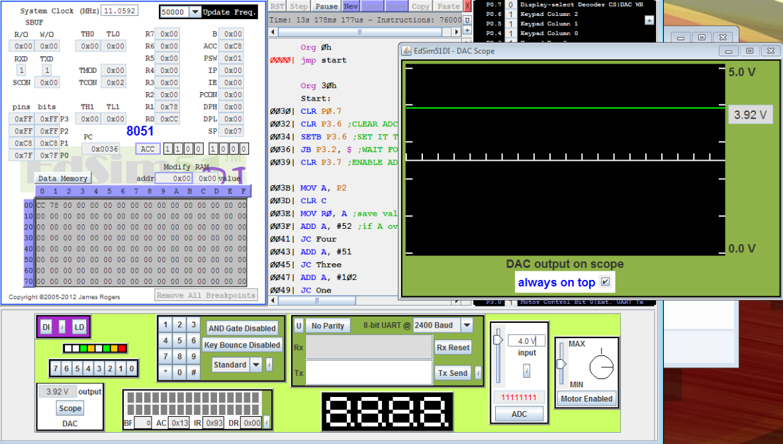

Output at 5V is 0V:
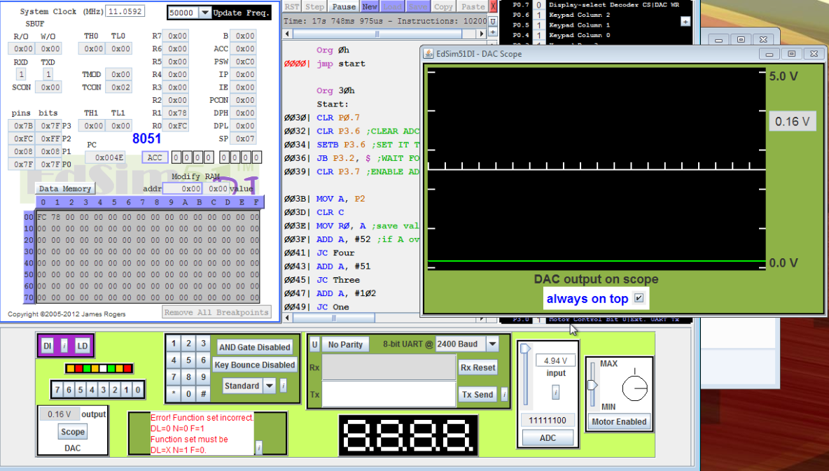

Conclusion:
This lab taught the basic functions necessary for converting from analog to digital and back. Also equally important, it taught basic signal processing in assembly. While in C++, these instructions could have been implemented much quicker using if statements, these statements had to be implemented in assembly through manipulation of flags, such as the carry flag. Basic multiplication and addition functions are much more difficult to program too because of the availability of only registers A and B to execute thee functions, as well as their limit of only being able to process 8 bit numbers. While these instructions are less intuitive to program, they are overall quicker to execute in assembly than in C because of more control over each machine cycle that is allowed in assembly.

Code:

Org 0h
jmp start
Org 30h
Start:
CLR P0.7
CLR P3.6 ;CLEAR ADC WR LINE
SETB P3.6 ;SET IT TO GENERATE A POSITIVE EDGE TO START CURRENT A/D CONVERSION
JB P3.2, $ ;WAIT FOR COMPLETION OF CURRENT CONVERSION
CLR P3.7 ;ENABLE ADC OUTPUT LINES TO ALLOW READING THE A/D CONVERSION RESULT
MOV A, P2
CLR C
MOV R0, A ;save value of Vin
ADD A, #52 ;if A overflows, Vin is greater than 4V
JC Four
ADD A, #51 ; If A overflows, Vin is greater than 3
JC Three
ADD A, #102 ; If A overflows, Vin is greater than1
JC One
JMP Zero
Four:
CLR A
MOV A, #0FFh ;20-4Vin = 4(5V-Vin)
SUBB A, R0 ;implementing 5V-Vin
MOV B, #4
MUL AB
MOV P1, A
JMP Finish
Three:
CLR A
MOV B, #3
MOV A, R0
MUL AB
CLR C
SUBB A, #098h
MOV P1, A
JMP Finish

One:
mov P1, #033h ; Constant term for 1<V<3
JMP Finish

Zero:
CLR A
MOV A, R0
MOV B, #4
MUL AB
MOV R1, A ;saves value of 4*Vin
CLR A
MOV A, #0FFh
SUBB A, R1
MOV P1, A
JMP Finish

Finish:
SETB P3.7
JMP START
End

