Report For Lab 6

Connor McCullough
EEN 312
3 April 2013

Objective:
Write a program to input information serially from a keyboard panel and output it to the text monitor panel. This program will be a simple calculator that processing the input characters, adds them together, and outputs the input characters as well as the solution to the problem. This program requires knowledge of setting the baud rate using a timer, as well as configuring hardware settings.

Equipment:
- Text editor and 8051 ASM assembler
- Step debugger to execute program one instruction at a time
- Data memory, accumulator, code memory
- Keyboard panel, Text monitor panel

Results:
Text before sent to 8051
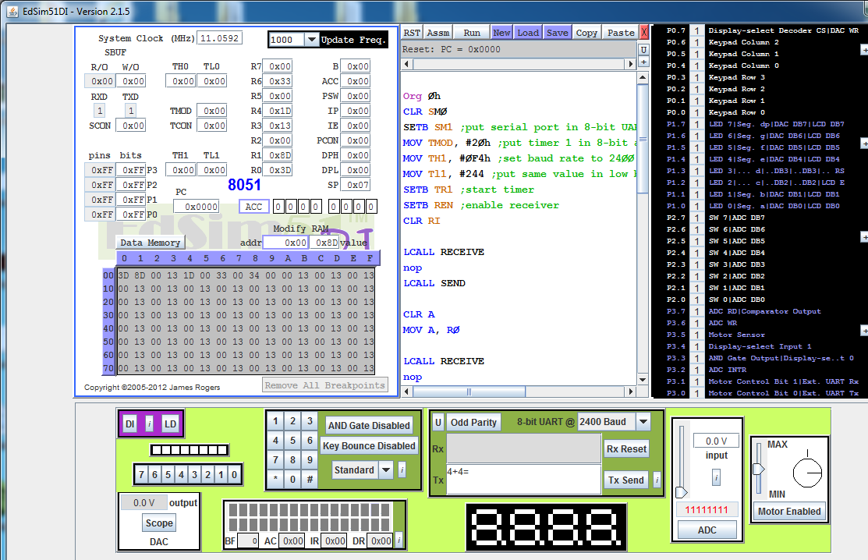
First character is read into program
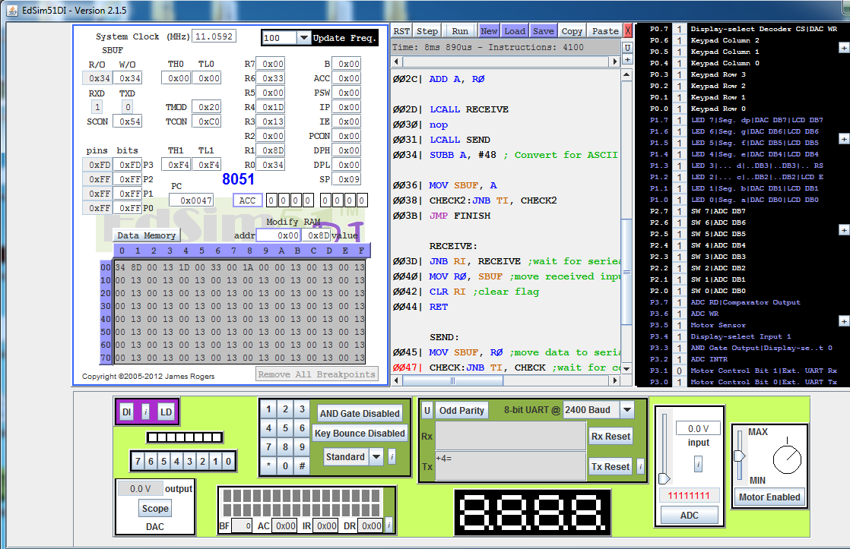

First character is printed to the text console, 2nd character read
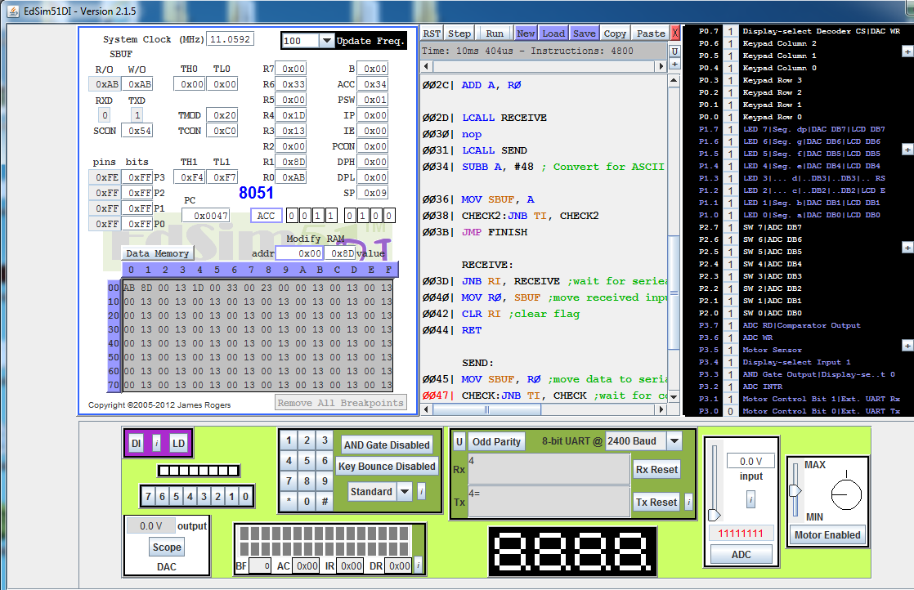
Second character is printed to the text console, third character read
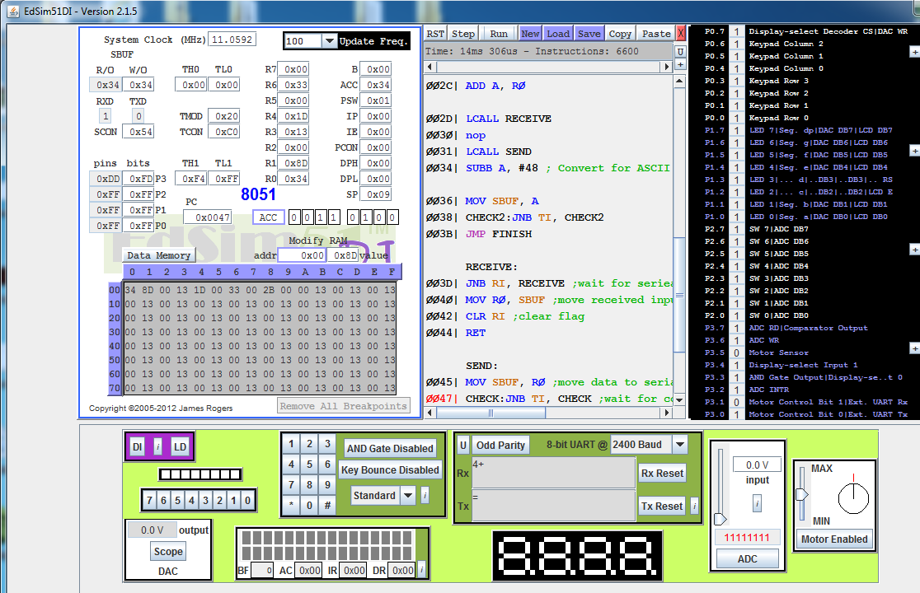

3rd character printed, last character read
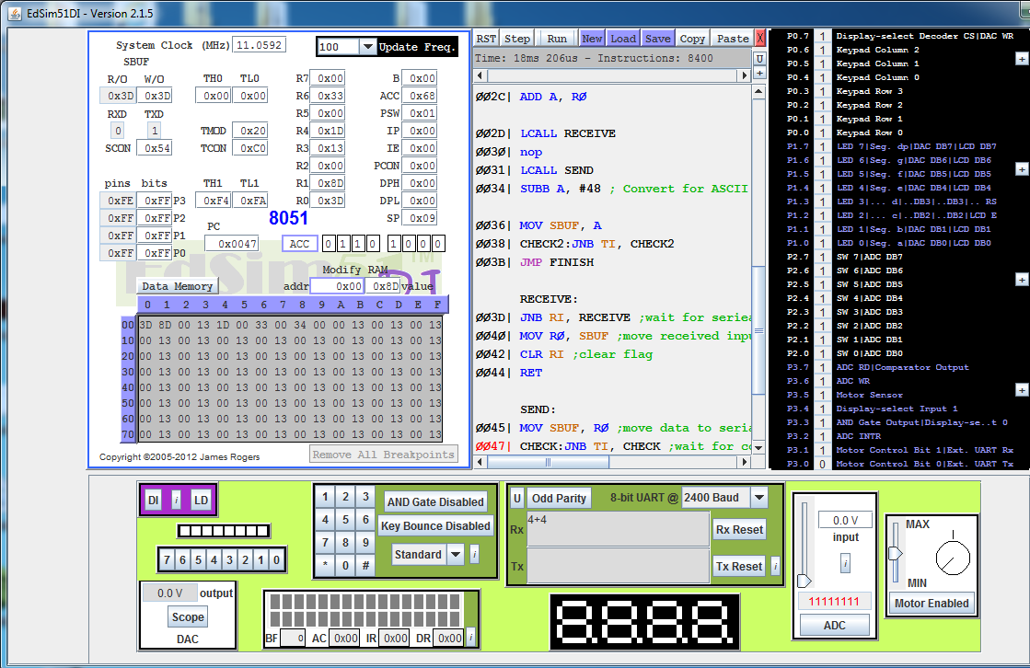
Print last character to console
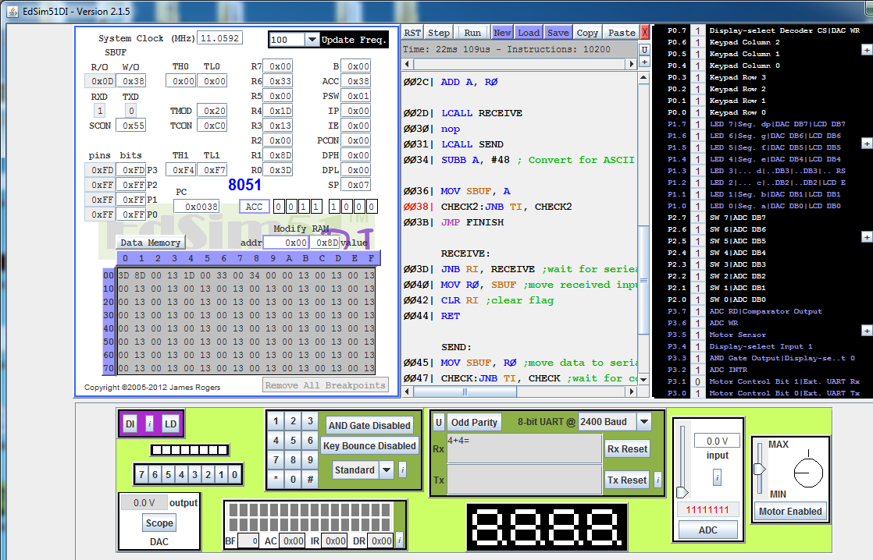

Print the sum to the console
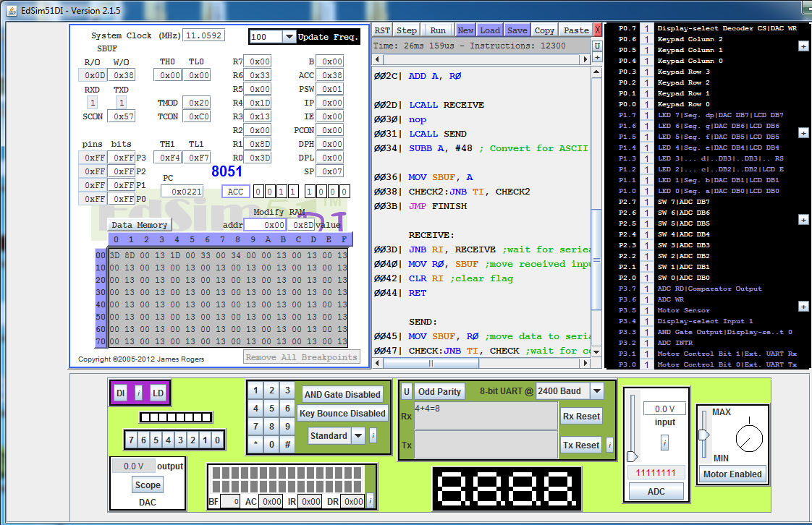

Conclusion:
This lab taught how to manipulate the timer registers to change the baud rate. Not only is the actual code used important, but making sure hardware and software are synchronized correctly. Even with the same code, the results can change if hardware is not synched correctly.

Code:

Org 0h
CLR SM0
SETB SM1 ;put serial port in 8-bit UART mode
MOV TMOD, #20h ;put timer 1 in 8-bit auto-reload interval timing mode
MOV TH1, #0F4h ;set baud rate to 2400
MOV Tl1, #244 ;put same value in low byte 8-bit auto reload timer
SETB TR1 ;start timer
SETB REN ;enable receiver
CLR RI

LCALL RECEIVE
nop
LCALL SEND

CLR A
MOV A, R0 ; Move first number to the accumulator

LCALL RECEIVE
nop
LCALL SEND
nop
LCALL RECEIVE
nop
LCALL SEND
nop

ADD A, R0 ; Add second number to first

LCALL RECEIVE
nop
LCALL SEND
SUBB A, #48 ; Convert for ASCII Code

MOV SBUF, A ; Output sum to Text module
CHECK2:JNB TI, CHECK2 ; Make sure character is sent before program finishes.
JMP FINISH

RECEIVE:
JNB RI, RECEIVE ;wait for serieal receiver flag to be 1
MOV R0, SBUF ;move received input char from serial input buffer to reg
CLR RI ;clear flag
RET

SEND:
MOV SBUF, R0 ;move data to serial output buffer to be transmitted
CHECK:JNB TI, CHECK ;wait for completion of translatio
CLR TI
RET

FINISH:
nop
End

