Report For Lab 5

Connor McCullough
EEN 312
18 March 2013
Objective:
Write two different programs that turns on different LED lights for periods of time by using the timer registers. This requires understanding how the timer in the 8051 functions.

Equipment:
Software:
- Text editor and 8051 ASM assembler
- Step debugger to execute program one instruction at a time
- Data memory, accumulator, code memory
- Built in LED lights

Results:
Part A: LED 0 is on for 1 second.
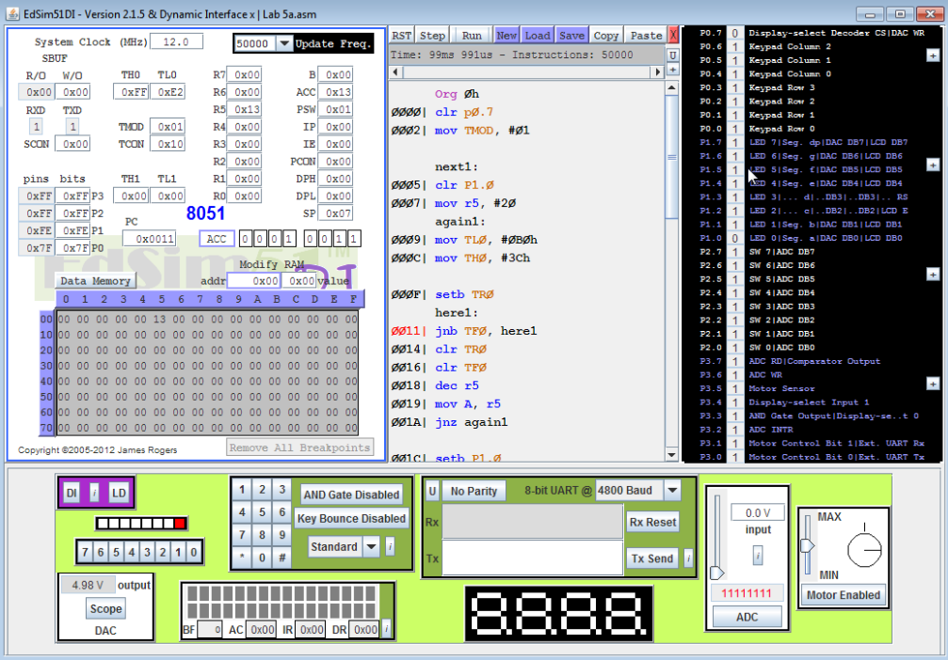
Part A: LED 1 is on for 1.5 seconds
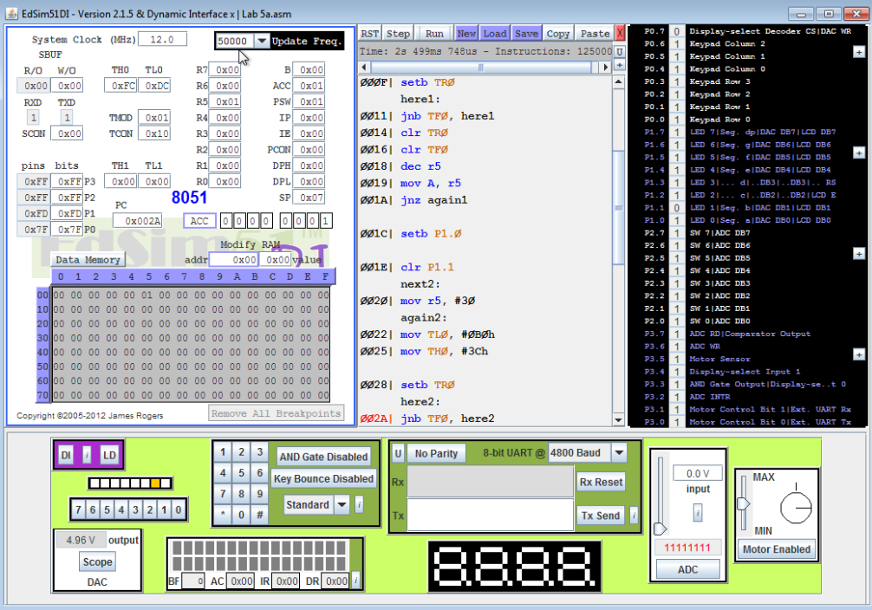
Part A: LED 2 is on for 2 seconds
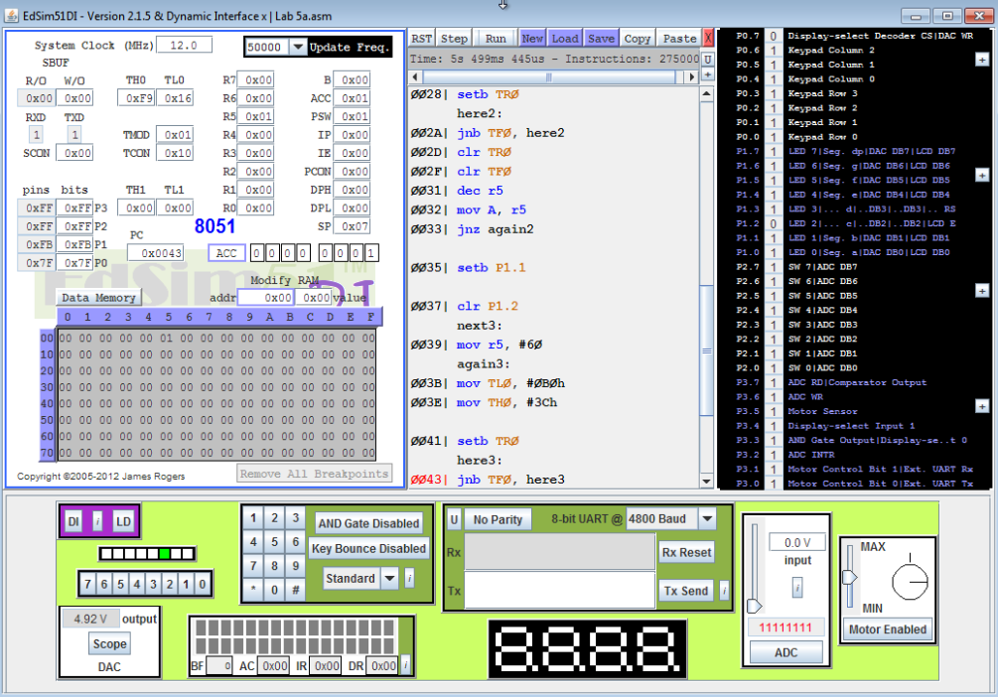
Part A: Sequence repeats indefinitely
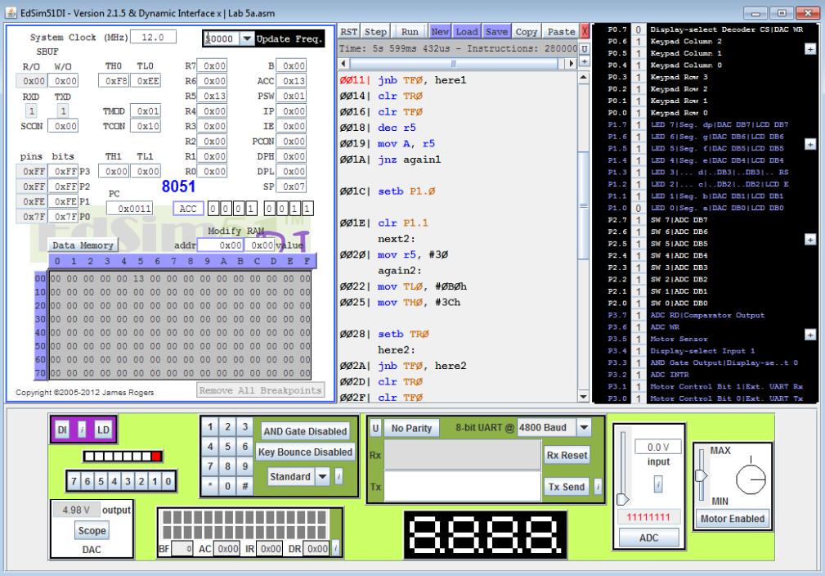

Part B: Light is off for one initially
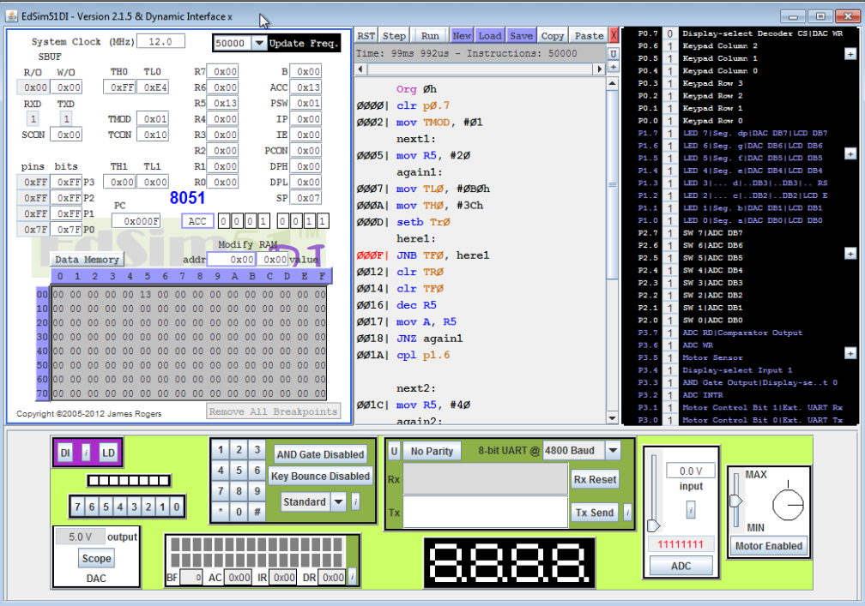
Part B: Light complimented after one second.
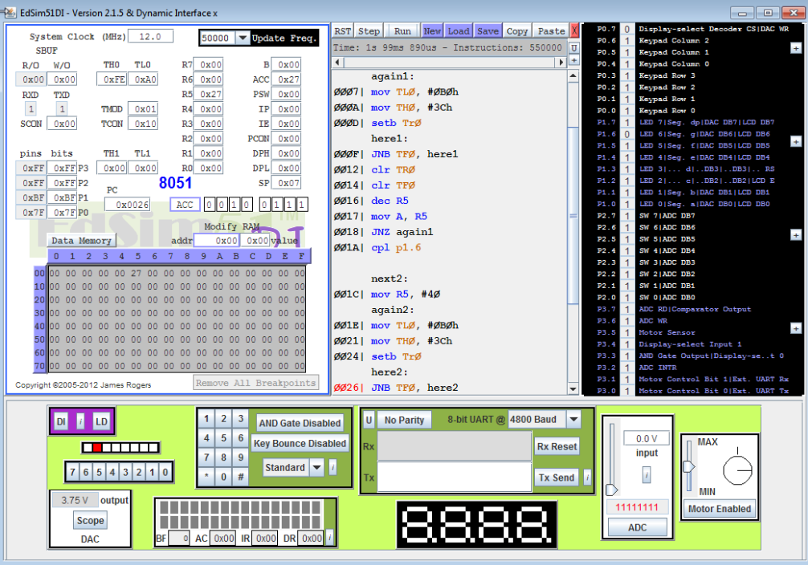

Part B: Light complimented again after 2 seconds
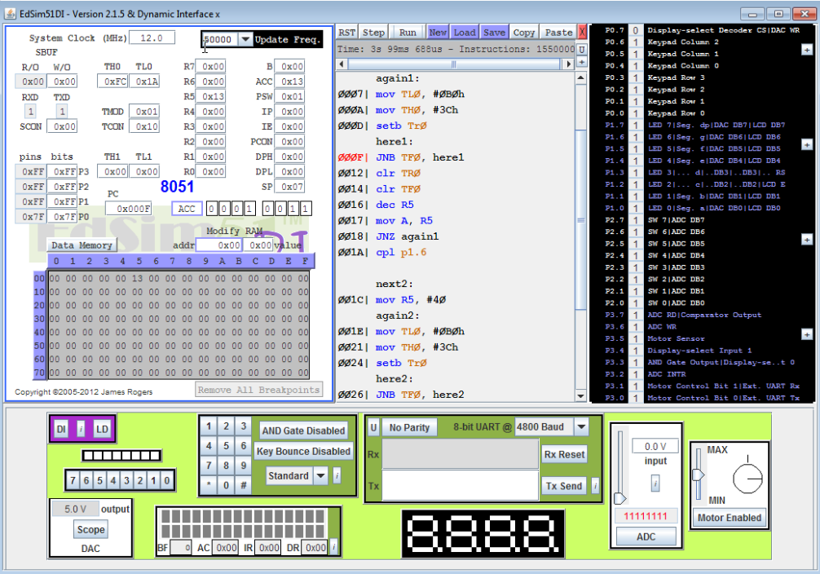
Part B: Light complimented again after 1 second.
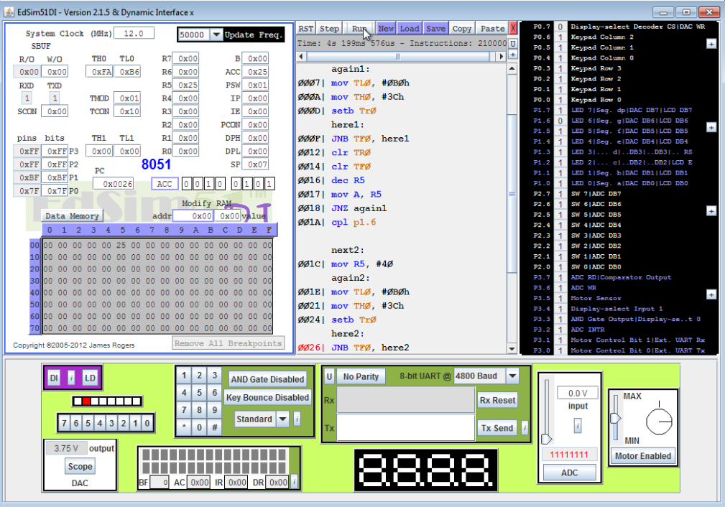
Conclusion:
This lab taught the importance of understanding how timers work in the 8051 so that operations can occur at normal intervals. The 8051 can’t just be told to wait a certain time, it has to loop until the timer has gone through a certain number of cycles. This requires knowledge of how long each cycle takes in order to calculate the number of times the timer has to loop.

Code:
Lab 5a
Org 0h
clr p0.7
mov TMOD, #01 ; Timer mode 1
next1:
clr P1.0 ; Turn on LED 0
mov r5, #20 ; Timer will be for 1 second based on this register
again1:
mov TL0, #0B0h
mov TH0, #3Ch
setb TR0
here1:
jnb TF0, here1
clr TR0
clr TF0
dec r5
mov A, r5
jnz again1 ; Do again loop 20 times by decrementing each time
setb P1.0 ; Turn off LED 0
clr P1.1 ; Turn on LED 1
next2:
mov r5, #30 ; Timer will go for 1.5 seconds
again2:
mov TL0, #0B0h
mov TH0, #3Ch
setb TR0
here2:
jnb TF0, here2
clr TR0
clr TF0
dec r5
mov A, r5
jnz again2
setb P1.1 ; Turn off LED 1
clr P1.2 ; Turn on LED 2
next3:
mov r5, #60 ; Timer will go for 3 seconds
again3:
mov TL0, #0B0h
mov TH0, #3Ch
setb TR0
here3:
jnb TF0, here3
clr TR0
clr TF0
dec r5
mov A, r5
jnz again3
setb P1.2 ; Turn off LED 2
LJMP next1 ; Start over at end
End

Lab 5b
Org 0h
clr p0.7
mov TMOD, #01
next1:
mov R5, #20 ; Timer will be for 1 second
again1:
mov TL0, #0B0h
mov TH0, #3Ch
setb Tr0
here1:
JNB TF0, here1
clr TR0
clr TF0
dec R5
mov A, R5
JNZ again1
cpl p1.6 ; Compliment P1.6

next2:
mov R5, #40 ; Timer will be for two seconds
again2:
mov TL0, #0B0h
mov TH0, #3Ch
setb Tr0
here2:
JNB TF0, here2
clr TR0
clr TF0
dec R5
mov A, R5
JNZ again2
cpl p1.6
ljmp next1 ; Keep doing indefinitely
End

