VI55: Class AB Push Pull Pentode Power Amp With Class A Preamp and Tone Stack
Connor McCullough, University of Miami, Coral Gables FL

ABSTRACT
While the majority of tube amplifiers are general purpose, the VI55 is a tube amp designed specifically for use in heavily downtuned guitar rhythm guitar playing. Specific attention to detail is taken in every step of the design process to introduce moderate amounts of distortion without harsh clipping. The most important aspect of the design process was to balance maximizing gain and distortion with avoiding harsh clipping characterized by discontinuities in the transient response and excess levels of Total Harmonic Distortion.

I. INTRODUCTION
The goal of this project was to design a high gain, high distortion tube amplifier for a rhythm guitarist, incorporating significant downtuning of the guitar. The preamp is a Class A Twin-Tube Preamp, while the Power Amp is Class B Push-Pull. The original goal of the preamp design was introducing voltage gain, as well as a moderate amount of distortion. However, clipping in the phase splitting section prevented excess voltage gain from the preamp. The preamp introduced moderate distortion and asymmetry as well as shaping the frequency response. Meanwhile, the phase splitting and power amplifier introduced significant amounts of gain as well as additional distortion, while preserving the frequency response of the preamp.
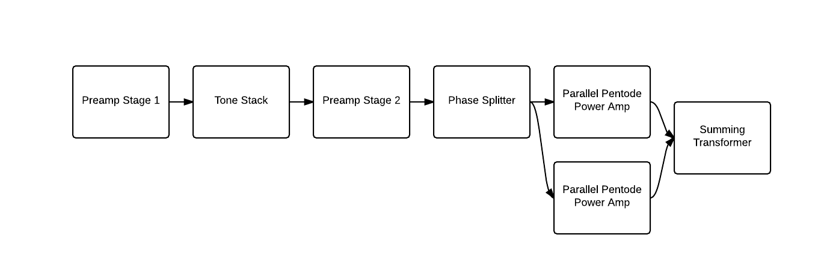Fig. 1. Block Diagram of VI55 Circuit

II. PREAMP
While typically, the cathode is biased to achieve maximum grid voltage swing, biasing for this particular preamp was done to achieve optimal response for a typical guitar using active pickups. The typical output for active pickups was found to be 500 mV.^{[1]} . Therefore, the grid voltage does not need to be at -1.5 volts to avoid exceeding 0 volts., as would be the case if the peak input was 1.5 volts. Because the input voltage is known, the Q point can be set to a variety of locations other than the point of maximum symmetrical swing. The preamp design is Two-tube Class A with negative feedback.

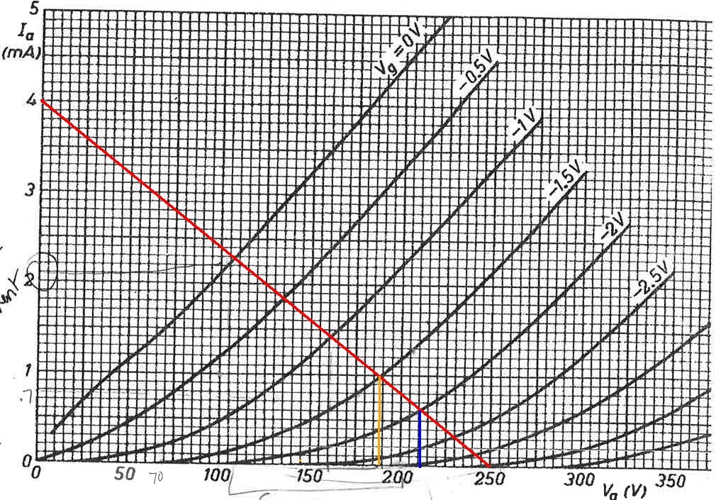
Fig. 2. Load line (red) and Q point(orange and blue) for VI55 Preamp design. Orange: Q point for stage 2, chosen based on maximum symmetrical swing. Blue: Q point for stage 1, chosen to optimally distort signal.

Several changes were made to the traditional design however to optimize performance. Because the guitar will at most be outputting 500 mV, a biasing of -1.5V will experience minimal distortion. The Q point was moved by increasing the value of the cathode resistor Rk so that the biasing is now at 2 Volts. As can be seen by the 12AX7 load line, operation is much less linear in the -2V grid voltage range.
The increased cathode resistor value on the first stage of the preamp shifted the Q point into the less linear operation point of the 12AX7, distorting half of the signal. Since design of the power amp will be facilitated by a predictable and symmetrical input signal, the other half of the signal must be shaped similarly by the second stage of the preamp (comparison of signal after both stages in fig. 7). This is relatively easy to achieve because the tube output already inverts the input signal. For the second stage of the preamp, the bias resistor was kept at the maximum symmetrical swing value (orange line in fig. 2). The distortion was optimized by modifying the two voltage divider potentiometers, one between the first two stages, and the second at the output of the preamp feeding back to the first stage.

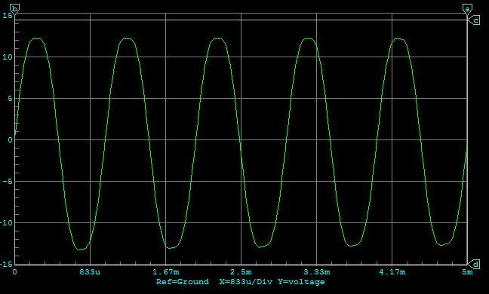
Fig. 3. Transient Response of Preamp Stage.
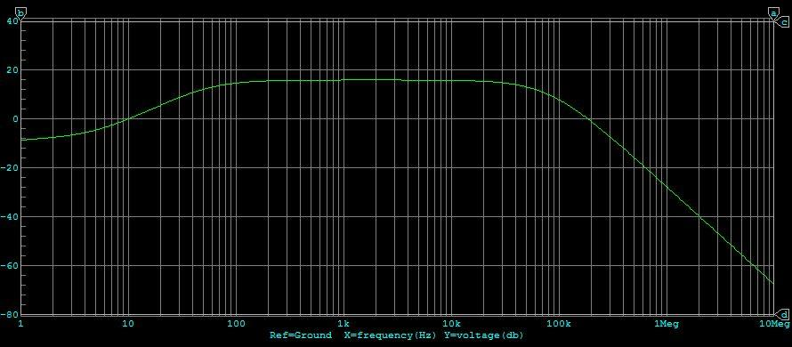
Fig. 4. Frequency Response of Preamp Stage.
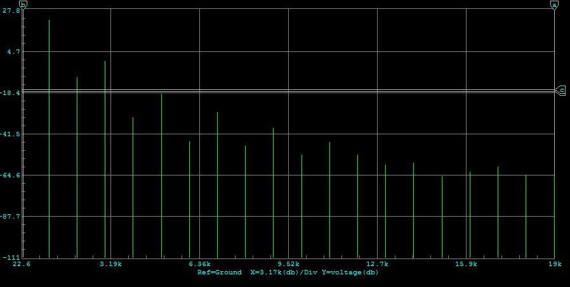
Fig. 5. Fourier Response of Preamp Stage With 1kHz Sine Wave input.
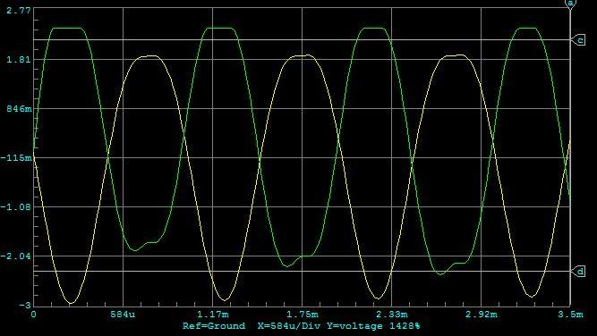
Fig. 6. Output After First Stage of Preamp (yellow) and second stage (green).
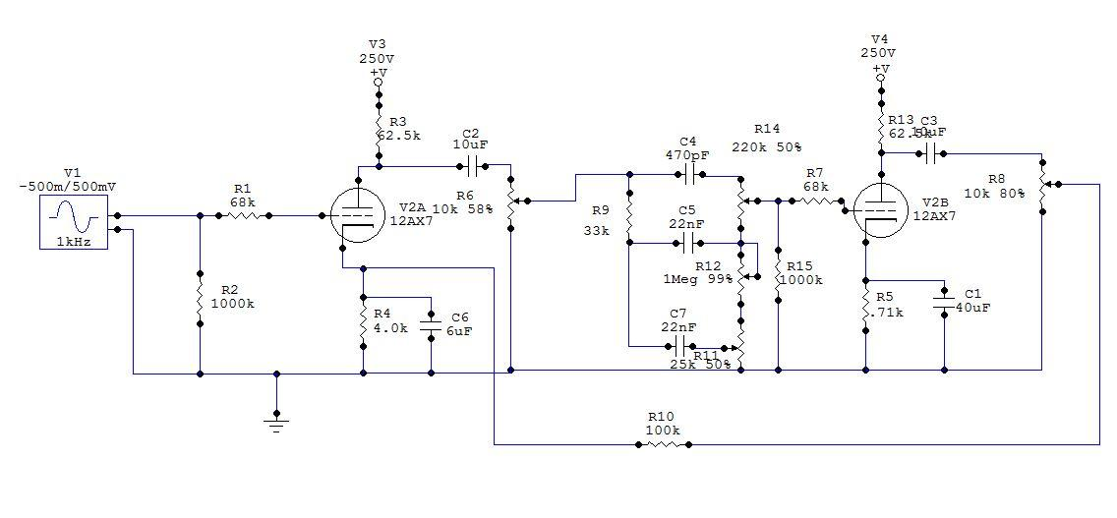
Fig. 7. Circuit Maker Simulation for Preamp and Tone Stack.

III. TONE STACK STAGE
The next step in the design process was to add a tone control between the two stages of the preamp. The circuit was based on the Marshall Tone Stack due to its desirable frequency response when all knobs are set to 50%. There is a significant boost between 50 and 100 Hz on the Marshall Tone Stack, which actually benefits the frequency response of the preamp even when all the knobs are set equally. The frequency response of just the preamp begins attenuating around 100 Hz.

The fundamental frequency of a guitar in standard tuning is 82 Hz, and an extended range or downtuned guitar may even reach as low as 55 Hz (A1) ^{[2]}. If the preamp is attenuating below 100 Hz, the clarity of the fundamental frequency is lost on these notes. So as well as giving the user freedom in adjusting their tone, the Marshall Tone Stack also boosts the fundamental frequencies of the lowest notes on the guitar even when the knobs are set equally.
However, the tradeoff of the Tone Stack is that it is a passive circuit, and therefore gain is lost, altering the amount of distortion from the second stage of the preamp. This can be compensated for by adjusting the voltage divider between the two stages and increasing the gain going into the tone stack. One final issue to consider is loading the second stage of the preamp. This can be solved by adding another 1M resistor to ground before the grid voltage, similar to that found at the input to the first stage.

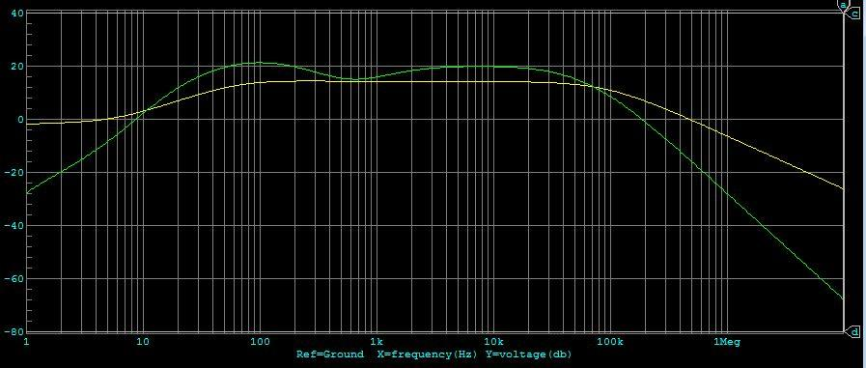
Fig. 8. Frequency Reponse before Tone Stack (yellow) and after (green).

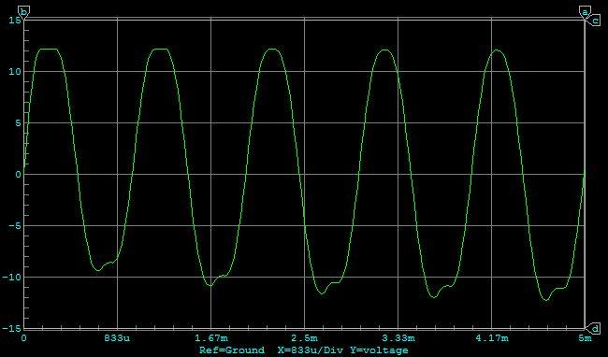
Fig. 9. Transient Response of Preamp and Tone Stack.

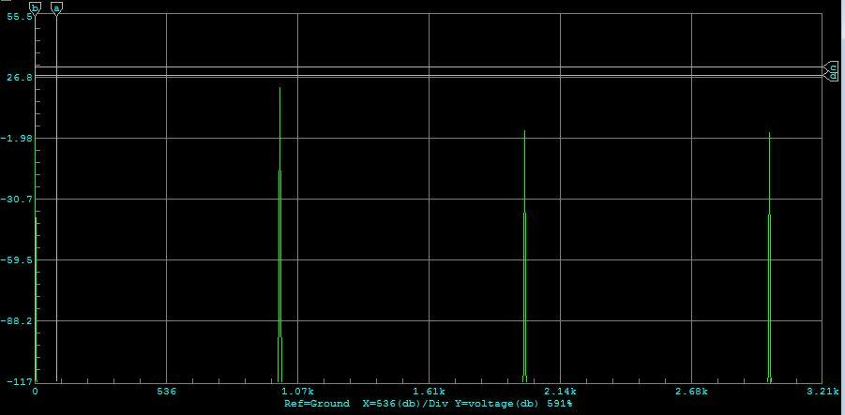
Fig. 10. Fourier Response of Preamp and Tone Stack.

IV. PHASE SPLITTER AND POWER AMP
The power amp stage is a Class AB Push-Pull Parallel Pentode Power Amp made up of a total of 6 tubes, two for phase splitting and the other two for power amplification. Because the preamp introduced some distortion, the goal of the power amplifier was also to introduce moderate, relatively symmetrical distortion with optimal voltage and power amplification. After some testing, it was determined that distortion introduced in the phase splitting phase produced a very angular and hard clipped output, resulting in much added high frequency response. Because the amplifier is geared towards warm, bottom heavy rhythm guitar playing, this would be undesirable. As a result, every aspect of the phase splitter and power amp was designed to minimize harsh clipping. First of all, the bias resistors for the phase splitter were set to avoid asymmetrical clipping. Additionally, the 6L6GC pentodes were biased to operate in a moderately linear range. Also, care had to be taken that the input to the phase splitter was not too much as to cause harsh clipping. While it was originally assumed that the preamp should produce a significant amount of voltage gain, this was not necessary, as the phase splitter and pentodes both produce a sufficient amount of gain on their own. By the end of the design, the main purpose of the preamp was seen to be shaping the distortion and overall frequency response of the signal, while the phase splitter and power amplifier stage provided the largest amount of gain. Additionally, the frequency response of the power amplifier turned out to be flat for the entire audible range above 100 Hz. As two systems in series have a frequency response of each of the individual systems multiplied by each other, the overall response turned out to be the first response, amplified with very low frequencies slightly attenuated.
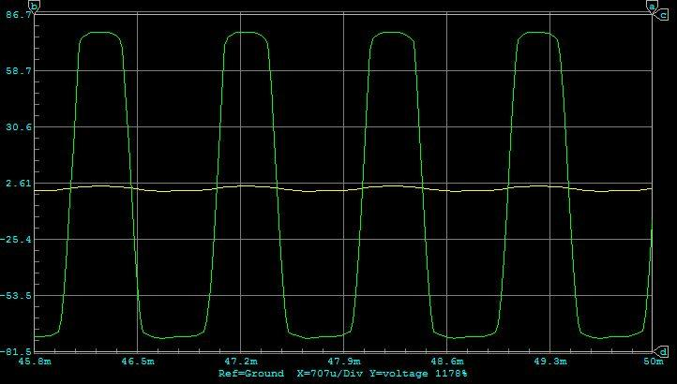
Fig. 11. Output of power amplifier (green) plotted against output of preamp (yellow).

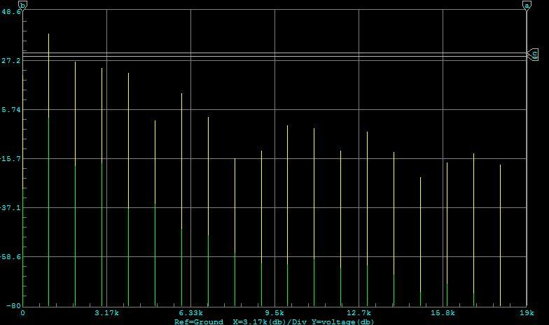
Fig. 12. Fourier response of power amplifier (yellow) plotted against Fourier response of the preamp (green).
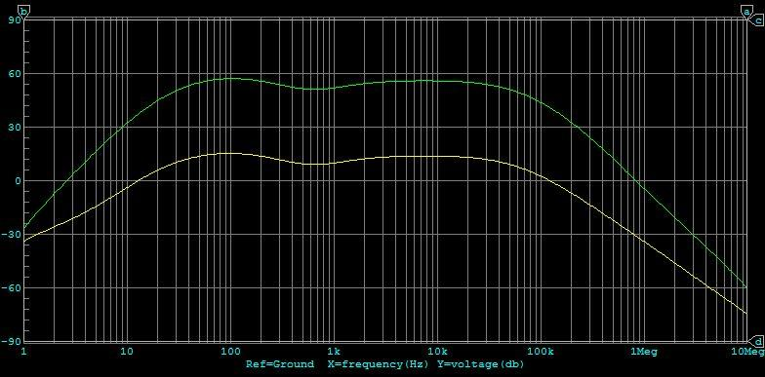
Fig. 13. Frequency Response of power amplifier (green) plotted against Frequency response of preamp (green).

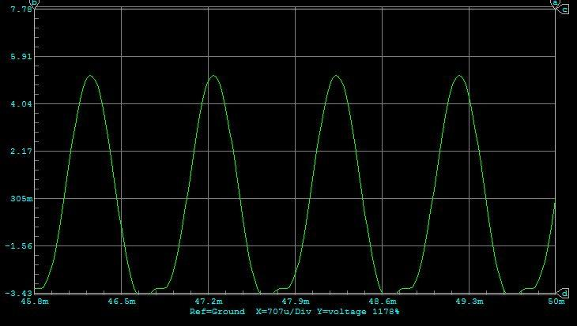
Fig. 14. Transient Response with Preamp Drive set to lowest position.
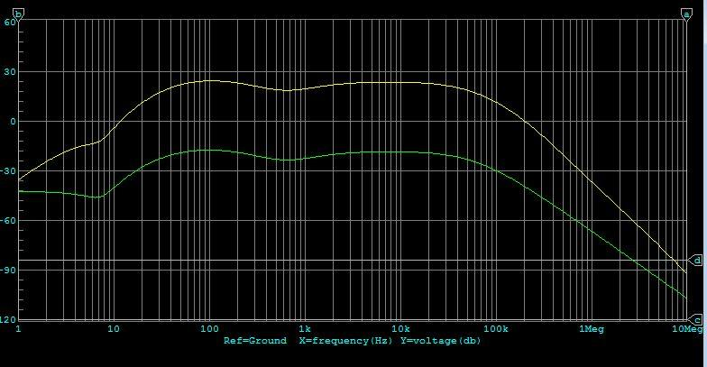
Fig. 15. Frequency Response with Preamp drive set to lowest position.
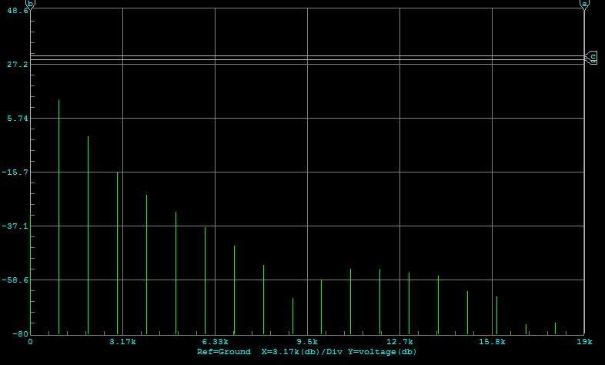
Fig. 16. Fourier Response with Preamp drive set to lowest position.

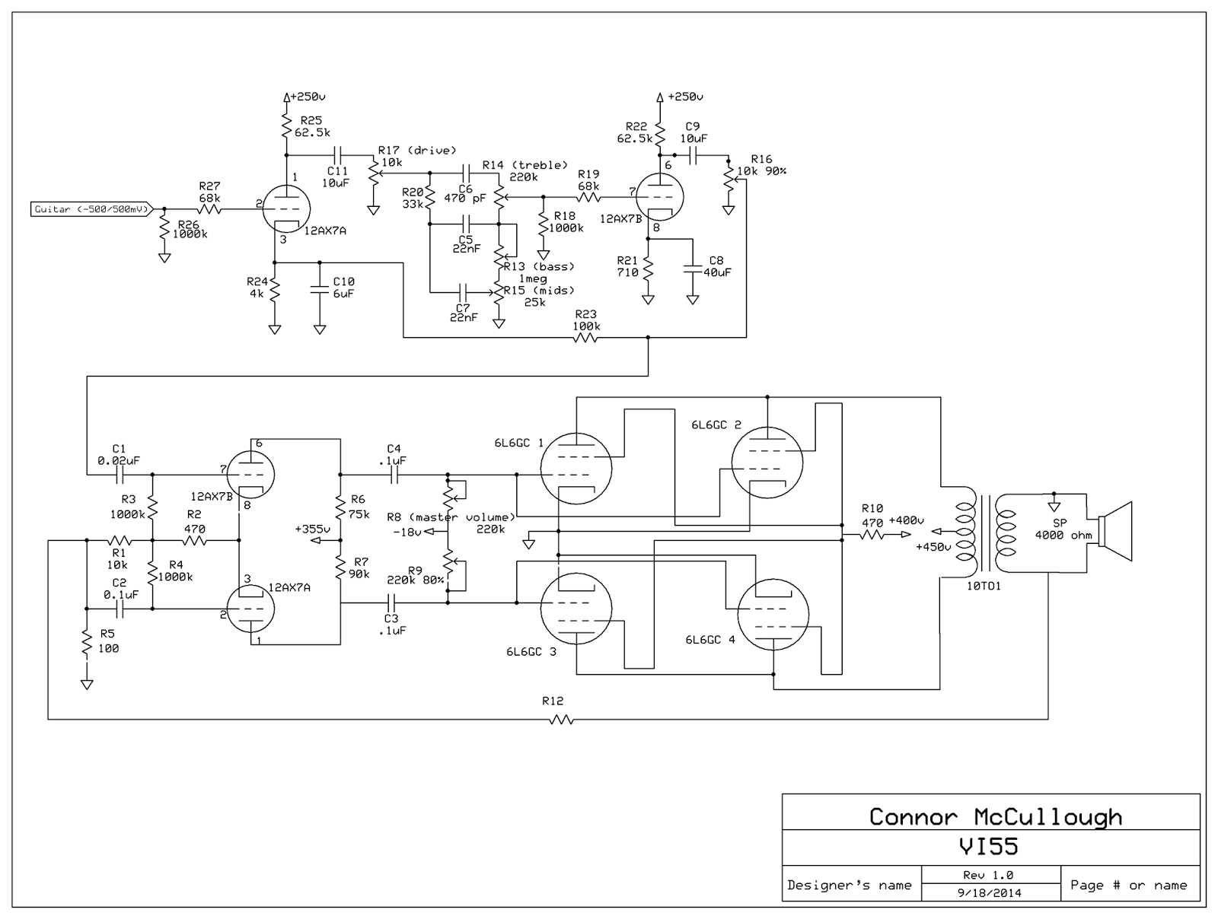
Fig. 17. Schematic for VI55

REFERENCES
^{[1]} http://www.electricalaudio.com/phpBB3/viewtopic.php?t=14124
^{[2]}http://www.phy.mtu.edu/~suits/notefreqs.html

