Description of Circuit:
The implemented circuit for this project is a one-bit full adder consisting of three half adders. The circuit has three inputs, and two outputs, one of which is a sum and the other which is carry. The circuit was implemented using a structural method, by creating entities for each gate and then calling upon the different components and mapping them together. This method lead to a very organized, straightforward, easy to understand program.

Structural Diagram:

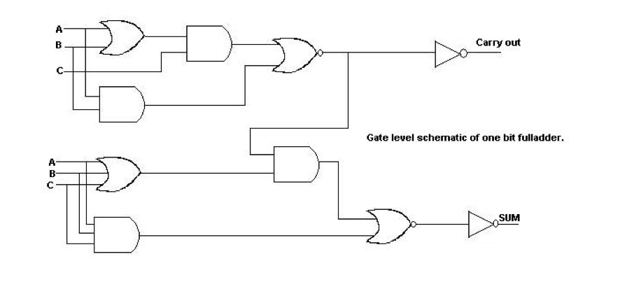

Code:
library ieee;
use ieee.std_logic_1164.all;
entity threeor is port
(A,B,C : in bit; sum,cout : out bit);
end threeor;
entity andgate is port
(in1, in2 : in bit; out1 : out bit);
end andgate;
entity norgate is port
(in1,in2 : in bit; out1: out bit);
end norgate;
entity orgate is port
(in1,in2 : in bit; out1: out bit);
end orgate;
entity notgate is port
(in1: in bit; out1 : out bit);
end notgate;

architecture behavior of andgate is
begin
out1 <= in1 and in2;
end architecture;
architecture behavior of norgate is
begin
out1 <= in1 nor in2;
end architecture;
architecture behavior of orgate is
begin
out1 <= in1 or in2;
end architecture;
architecture behavior of notgate is
begin
out1 <= not in1;
end architecture;

architecture fulladder of threeor is

component andgate is port
(in1, in2 : in bit; out1 : out bit);
end component;
component orgate is port
(in1, in2 : in bit; out1 : out bit);
end component;
component norgate is port
(in1, in2 : in bit; out1 : out bit);
end component;
component notgate is port
(in1 : in bit; out1 : out bit);
end component;
signal d,e,f,g,h,i,j,k:bit;

begin
or1 : orgate port map(A,B,d);
and1: andgate port map(A,B,e);
and2: andgate port map(C,d,f);
nor1: norgate port map(e,f,g);
not1: notgate port map(g,cout);
or2: orgate port map (C,d,h);
and3:andgate port map(C,e,i);
and4: andgate port map(g,h,j);
nor2: norgate port map(i,j,k);
not2: notgate port map(k,sum);
end fulladder;

Simulation:

0+0+0
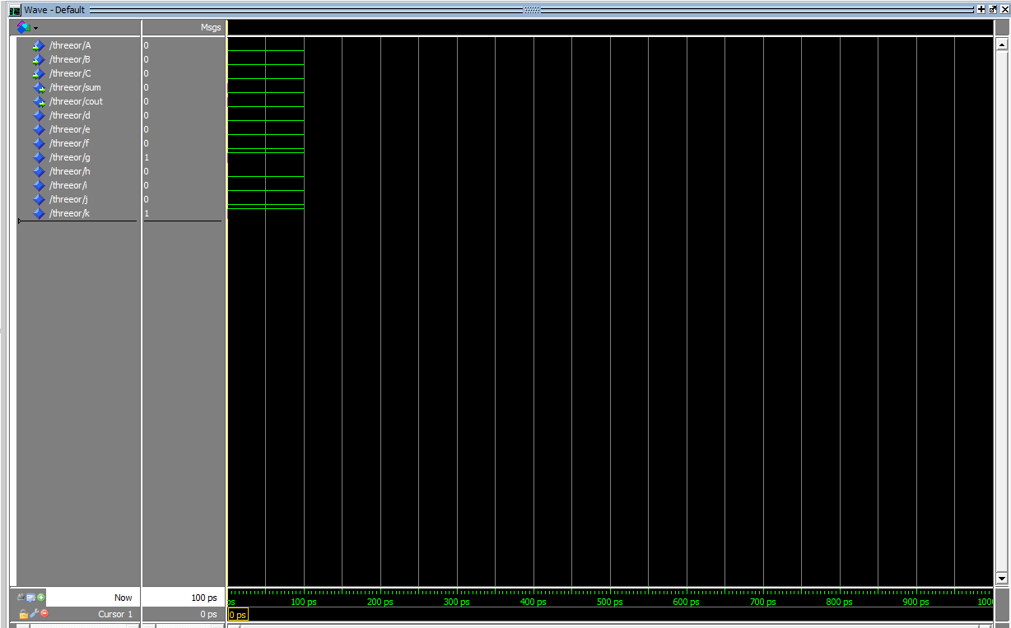

1+0+0
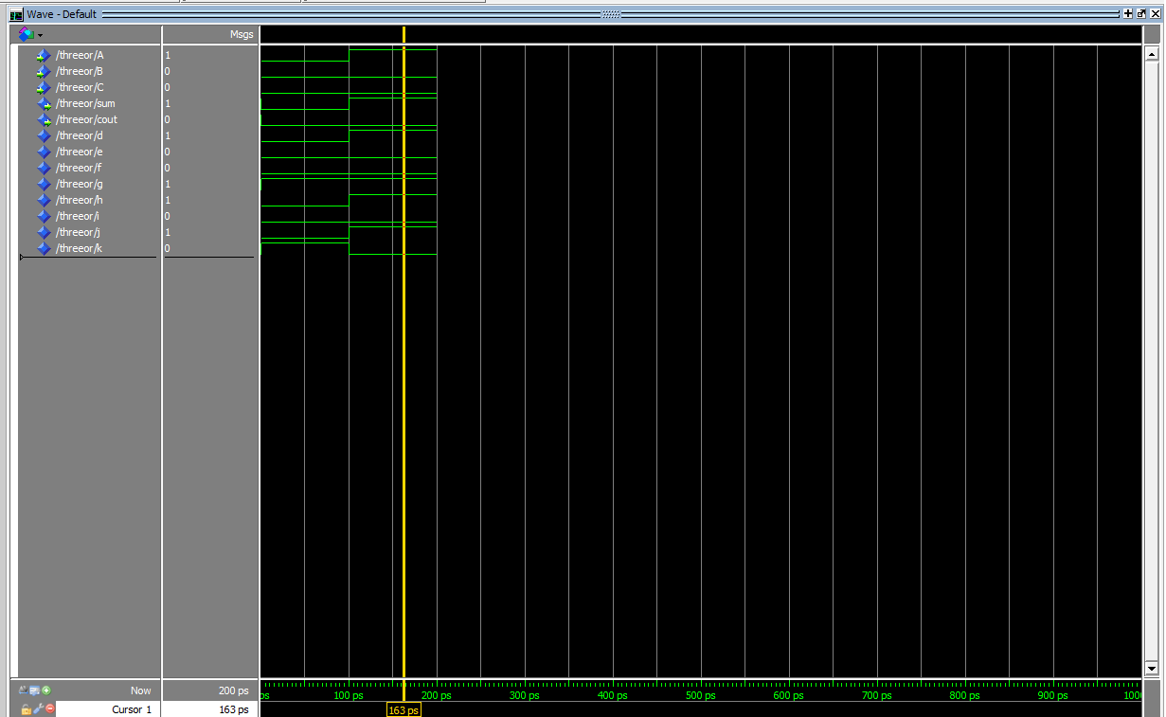

1+1+0
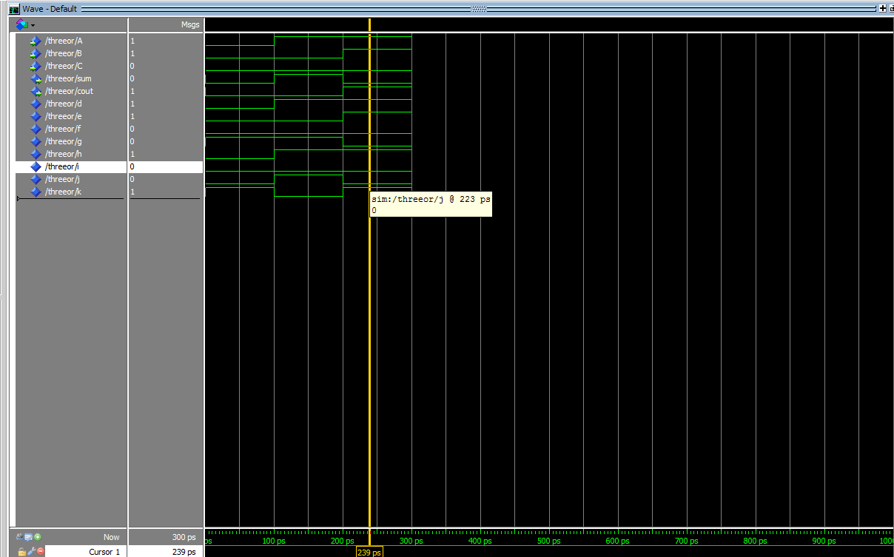

1+1+1
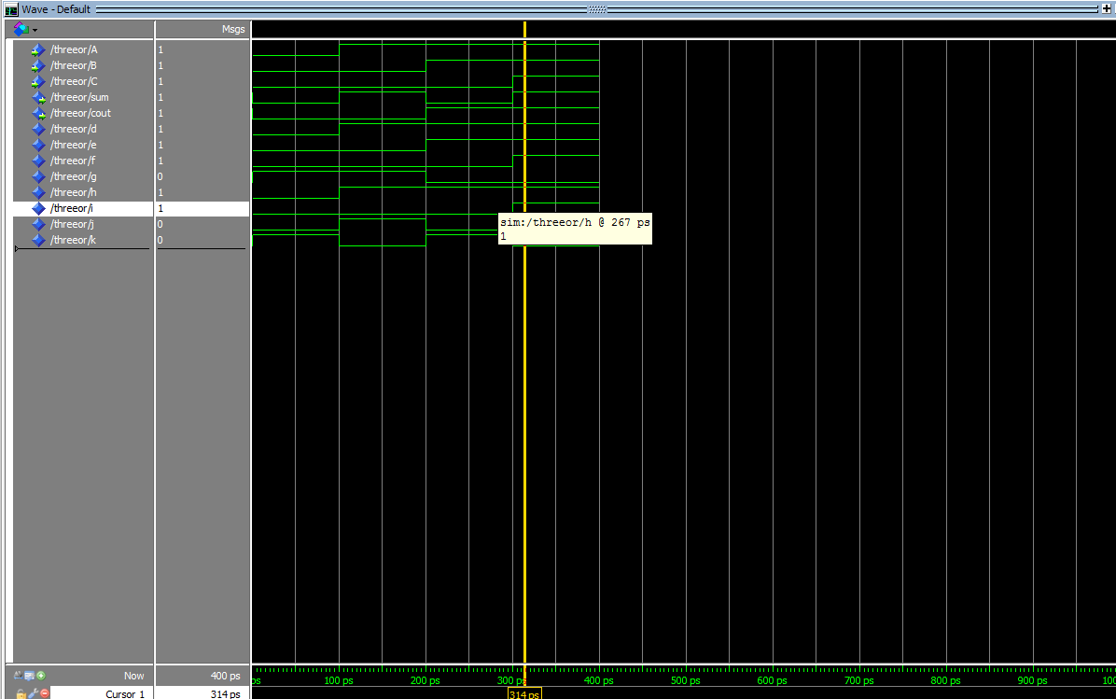

Results:
The inputs 0+0+0, 1+0+0, 1+1+0, and 1+1+1 were tested. 0+0+0 returned 0 and 0 for both sum and carry out. 1+0+0 returned 1 for sum and 0 for carry. 1+1+0 returned 0 for sum and 1 for carry. 1+1+1 returned 1 for both sum and carry.

