Connor McCullough
EEN 436
31 March 2014

DSP Homework 4

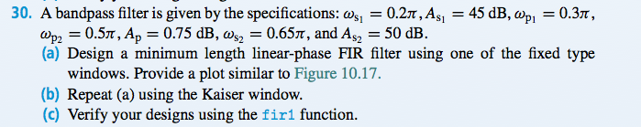
a) Using fixed-type window:

Magnitude Response (dB):
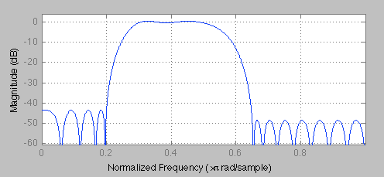
Impulse Response:
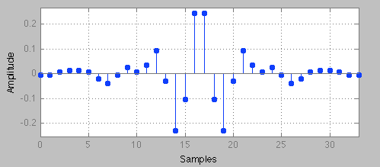

Lower zoom of Magnitude Response (dB):
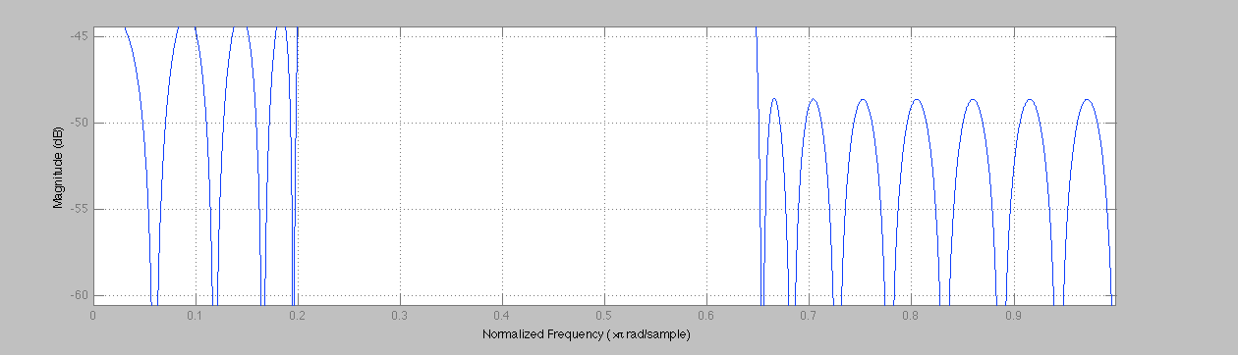

Upper zoom of Magnitude Response (dB):
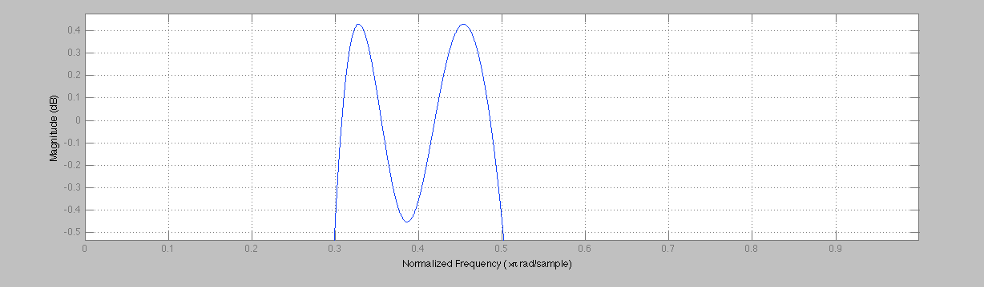

Error function:
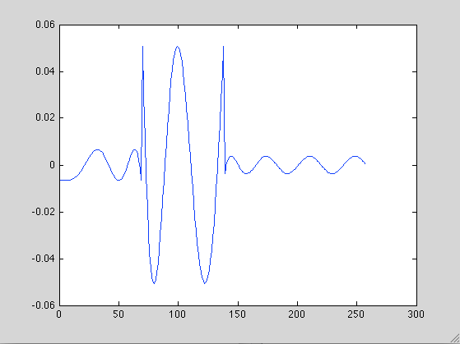

b) Using Kaiser Window:

Magnitude Response(dB):
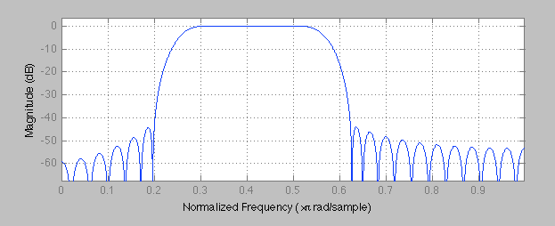

Impulse Response:
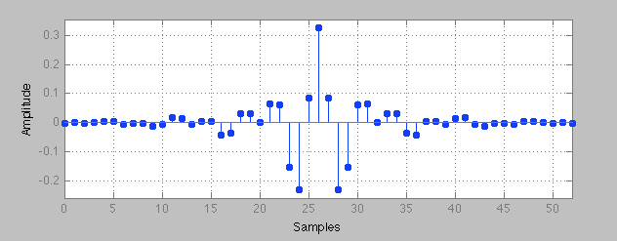
Lower Zoom of Magnitude Response (dB):
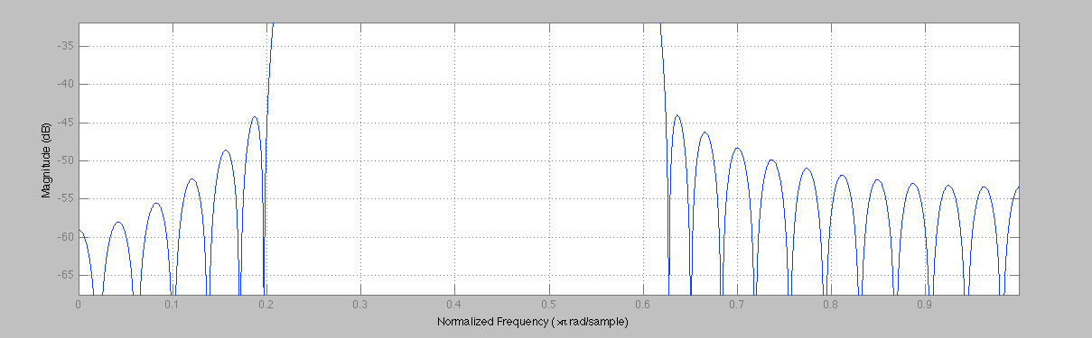
Upper Zoom of Magnitude Response (dB):
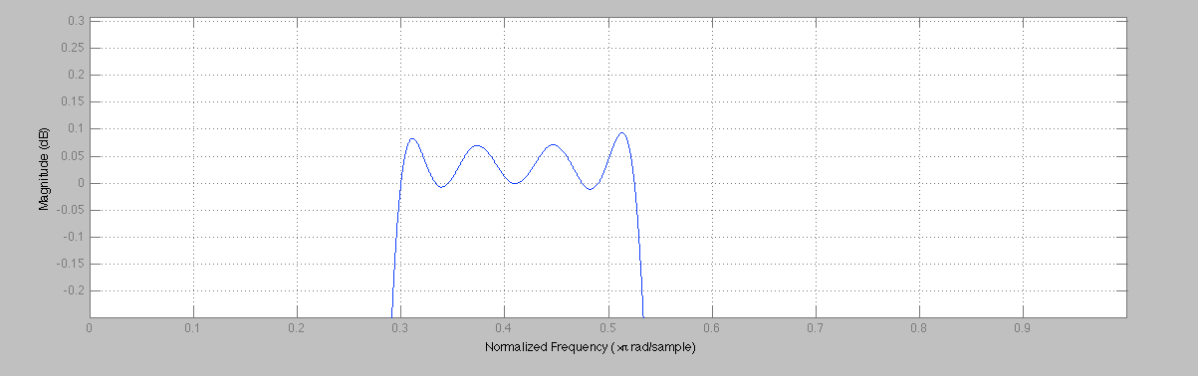

c) Verified with fir1 function:
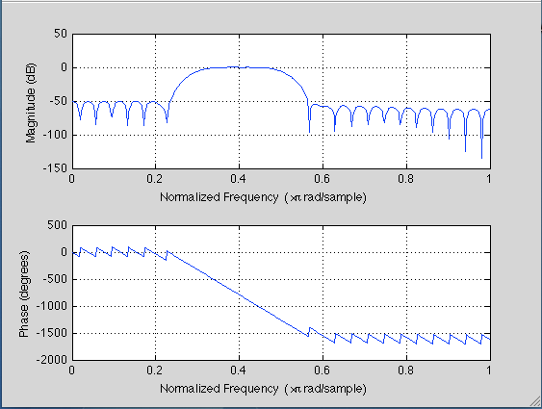

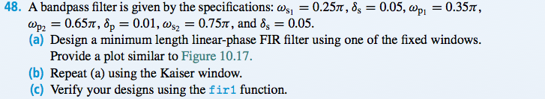
a) Using fixed window:

Magnitude Response(dB):
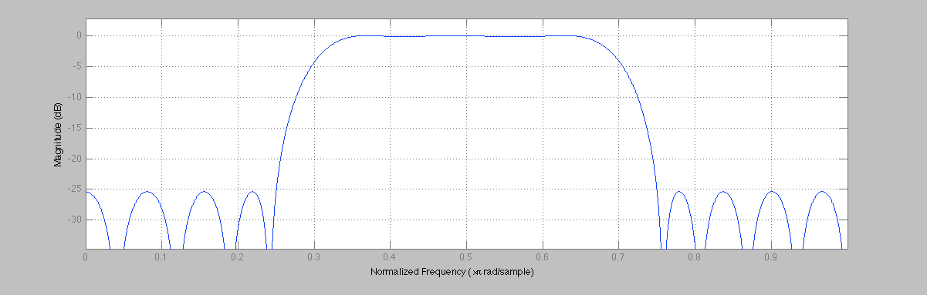
Impulse Response:
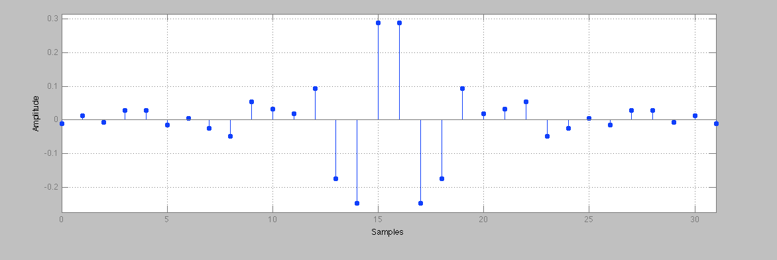
Upper Zoom of Magnitude Response(dB):
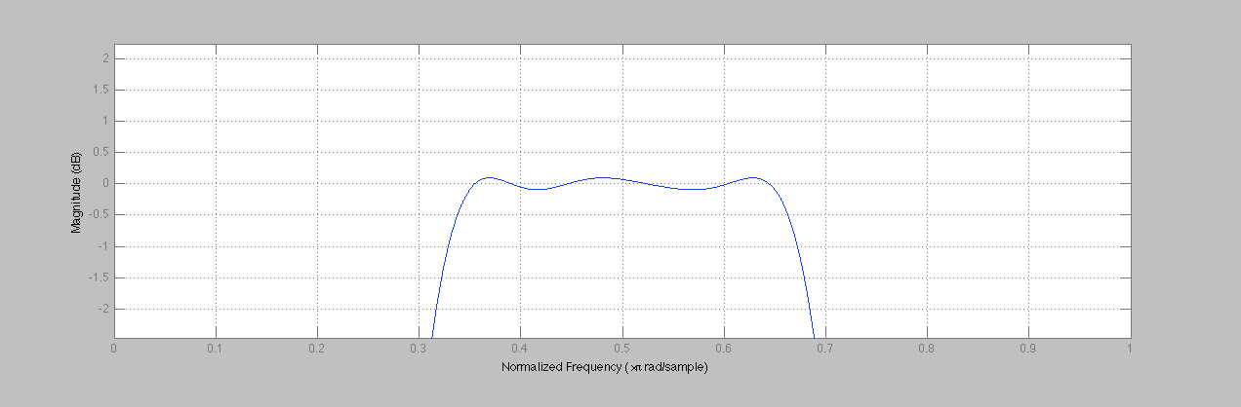
Lower Zoom of Magnitude Response (dB):
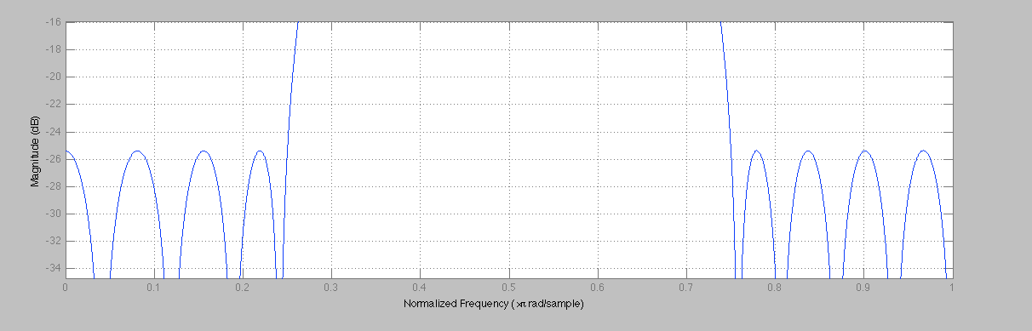
Approximation Error:
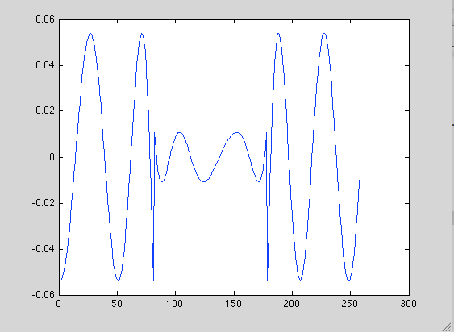

b) With Kaiser window:

Magnitude Response (dB):
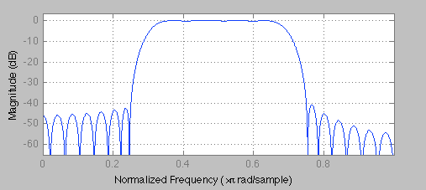
Impulse Response:
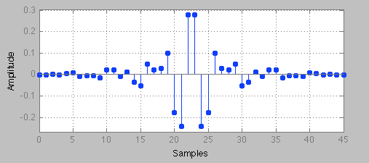
Lower Zoom of Magnitude Response (dB):
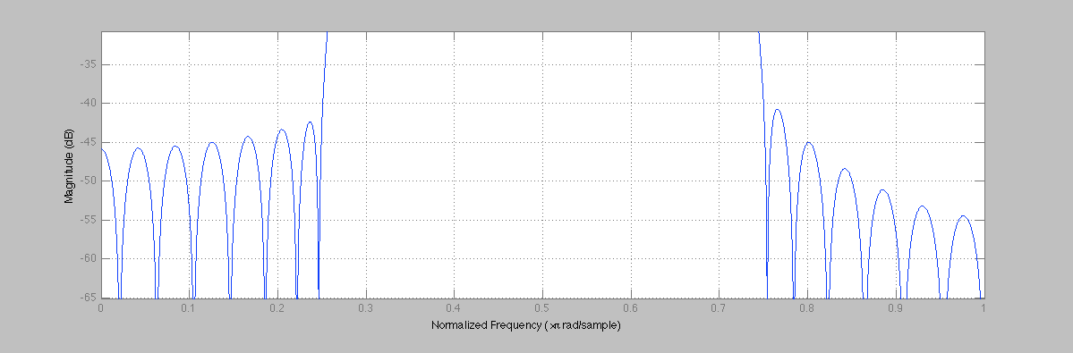

Upper Zoom of Magnitude Response (dB):
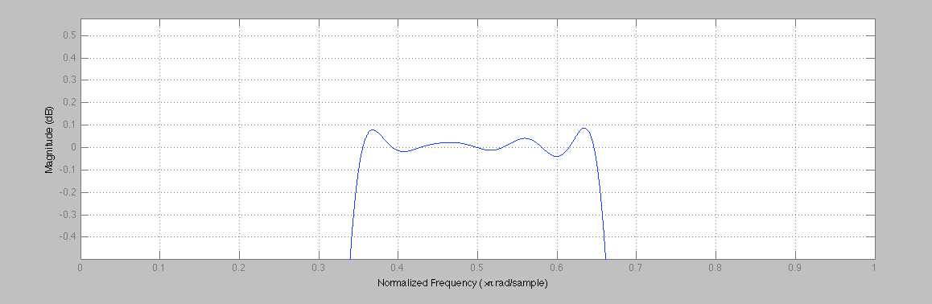

c) Verified with fir1:
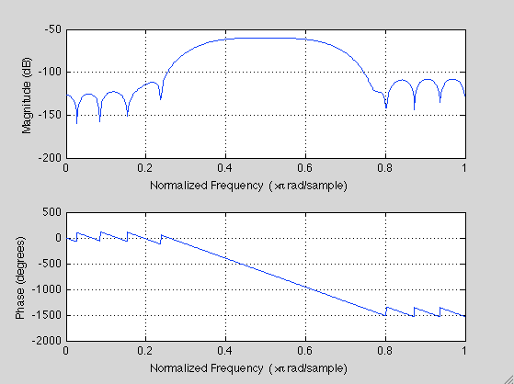

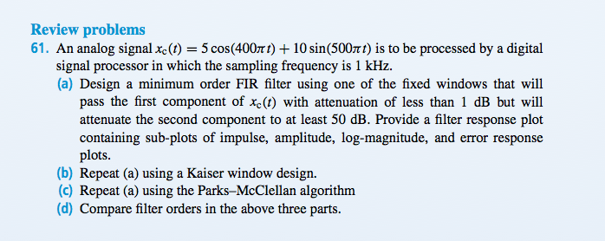

a/b) Using fixed window:

Magnitude Response (dB):
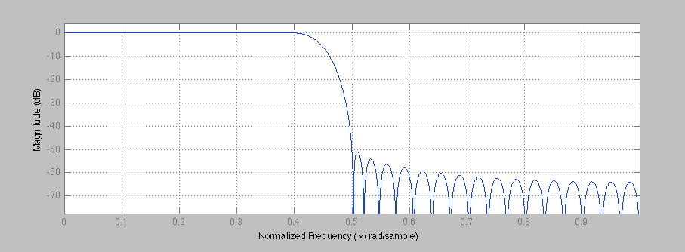
Impulse Response:
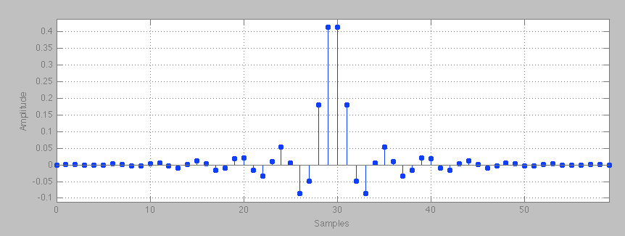

Amplitude:
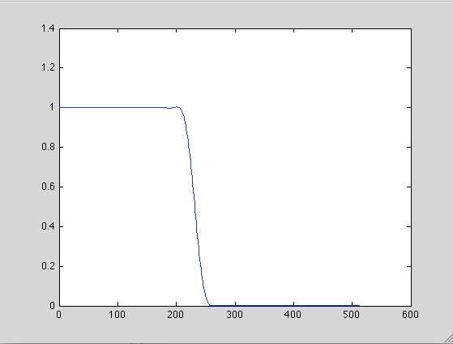

c) Using Parks-McClellan algorithm:

Magnitude Response (dB):
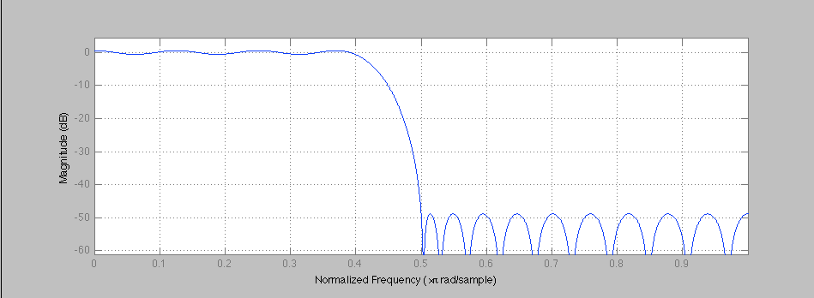

Impulse Response:
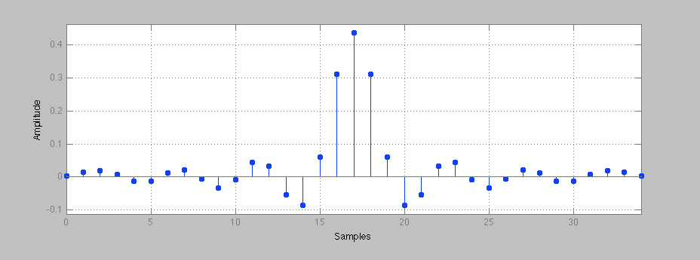
Amplitude:
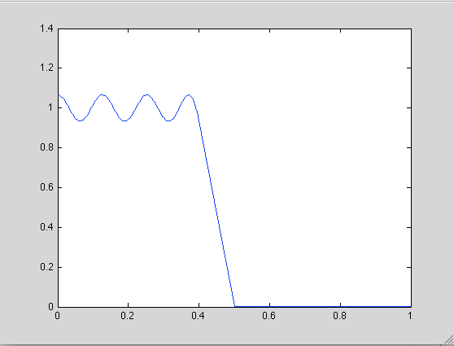

Error Response:
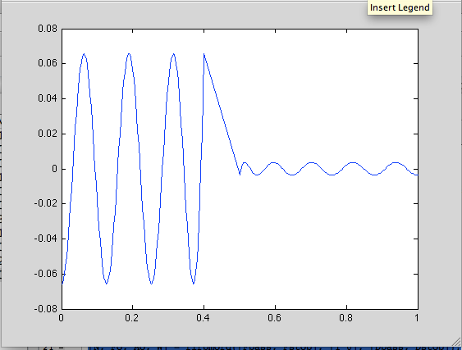
d) PM uses 34th order, Kaiser uses 59th order.
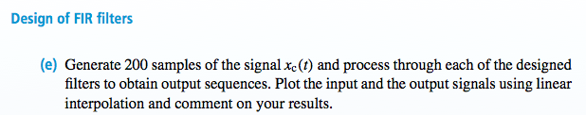

Filtered/Unfiltered using Parks-McClellan:
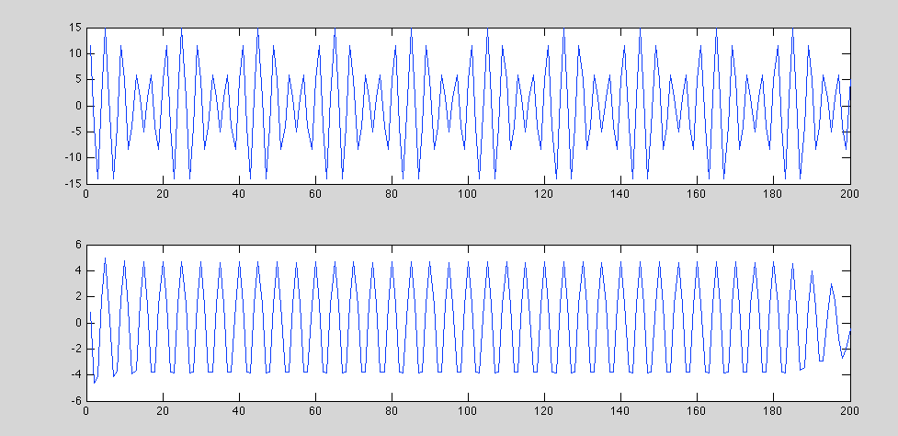

Filtered/Unfiltered using Kaiser:
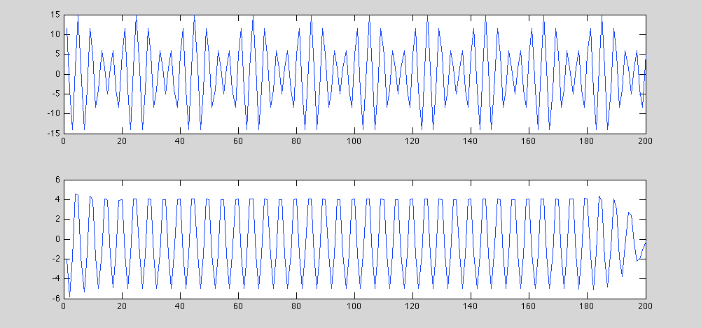
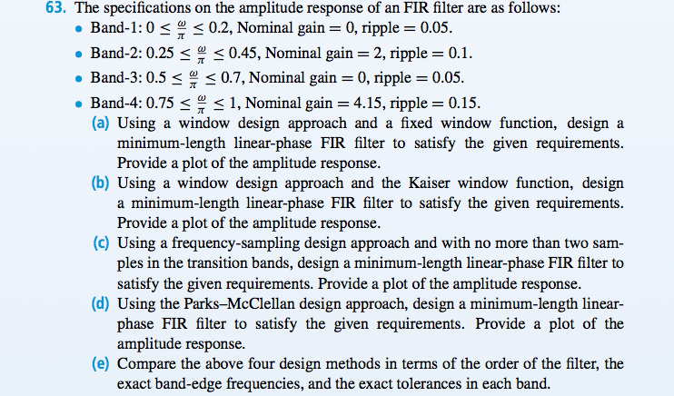
d) Using Parks-McClellan: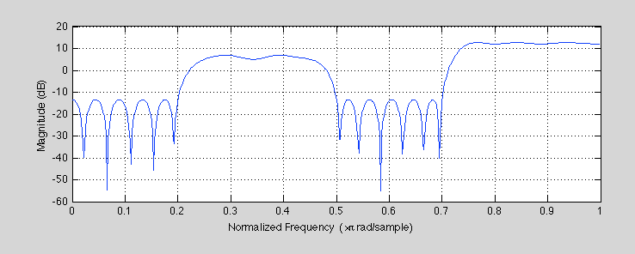

e) Parks McClellan: 46th order

