Digital Design Lab
EEN 315 Section 47

Project 1
Shift Register &
Signature Analyzer

Group #2
Connor McCullough
(Partner: Joe Barra, Connor McCullough,
Davis Sprague, Nick Hetko)

May Lin, TA
University of Miami
March 31, 2014
Abstract
The purpose of this project was designing a shift register and signature analyzer using the Quartus II software to simulate various integrated circuits, logic components, and connections, as opposed to actual physical circuit components and a breadboard. The shift register required directional control for the direction of the shift, as well as a load control to switch between serial and parallel input. The signature analyzer takes a binary input also known as a probe and then tests that the shift register is functioning correctly.

Overview
The shift register was designed with multiplexers, D flip-flops, and XOR gates. The signature analyzer produced outputs depending on the type of input probe used.

Objectives
The objective was to learn how to simulate a circuit using the Quartus software. The lab required simulation of a bi-directional shift register that would accept serial or parallel inputs. The shift register was then fed into the signature analyzer to use the sequences as a probe.

Equipment
Description | Quantity
2:1 Multiplexors | 8
4:1 Multiplexor | 1
D Flip Flops | 4
XOR gate | 2

Description
The first step for the lab was to learn how to use the Quartus software. Next, the shift register was implemented by testing each individual cell of the register. Each cell was made with 2:1 multiplexors and a D flip flop. The first 2:1 multiplexor allows choosing left or right shifting, and the second allows serial or parallel input. The flip flop stores the output of the multiplexors and is synchronized by the clock. Once one cell was completed, the others were just copies. The output of the last cells were connected to the input of the next.
Next, the signature analyzer was implemented using XOR gates. “Pseudo-random” input signals were given and sent to the probe input to test if the analyzer was working properly.

Specifications
The shift register cells and pseudo-random inputs were given but nothing else.

Design Synthesis

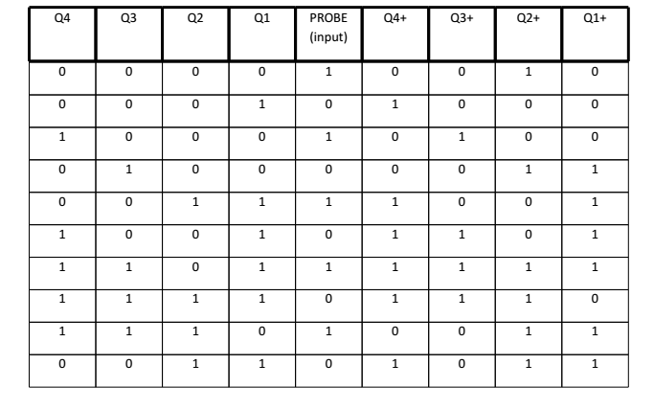

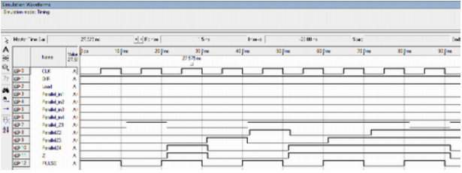

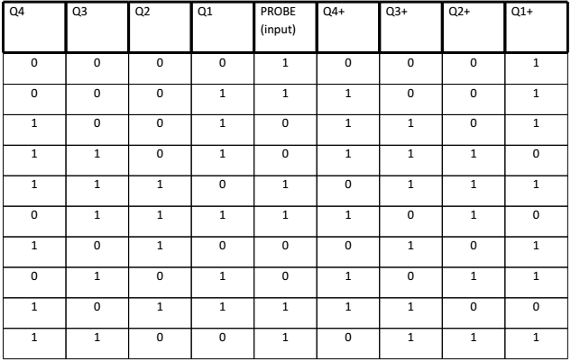

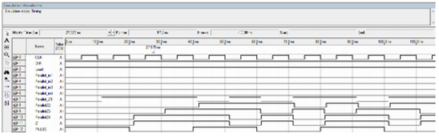

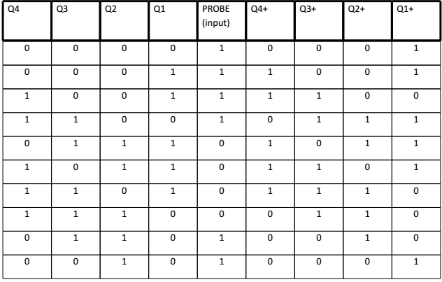

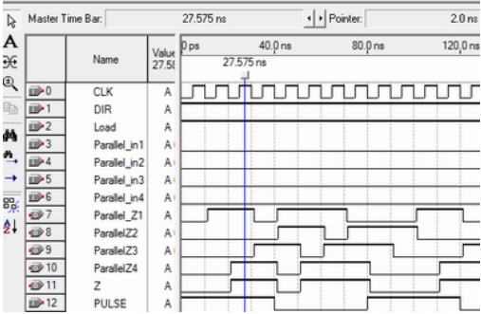

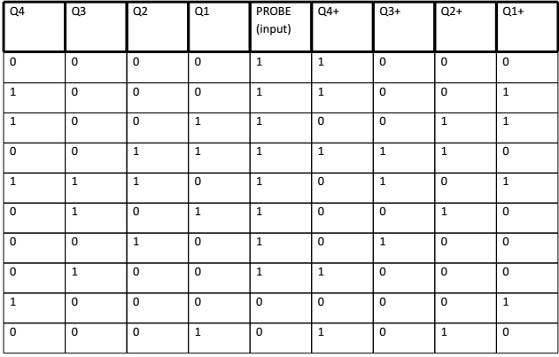

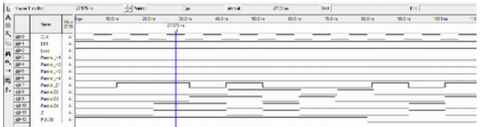

Conclusion
This lab helped familiarize us with the Quartus software. The biggest advantage of this software was that redundant items such as the cells in the shift register that were used multiple times can be easily copied. This makes Quartus suitable for larger scale digital circuit design and testing because of the ease in copying smaller parts of the project. Using real components, it would take equally long to make every instance of the cell since real components are being used.

