Report For Lab 3

Connor McCullough
EEN 312
20 February 2013

Objective:
Implement code for a functioning set of stoplights, that when receiving input cues, will cycle through the different light colors as a real stoplight would. This code will be implemented using subroutines, the call function, and the jump function.

Equipment Used:
Software:
- Text editor and 8051 ASM assembler
- Step debugger to execute program one instruction at a time
- Data memory, accumulator, code memory

Flow Chart:

P1.2=0
P1.3=0

CALL TEMPO

CALL TEMPO
P2.2=1 set?

P2.1=1set?
P1.1=0
P1.3=0

CALL TEMPO
CALL TEMPO
CALL TEMPO
P1.0=0
P1.4=0
P1.1=0
P1.3=0
P1.1=0
P1.3=0

CALL TEMPO

CALL TEMPO

P1.0=0
P1.3=0
P1.0=0
P1.3=0

P1.2=0
P1.3=0
CALL TEMPO

CALL TEMPO
P1.0=0
P1.5=0

CALL TEMPO

P2.0=1set?

Results:
P2.1=1:

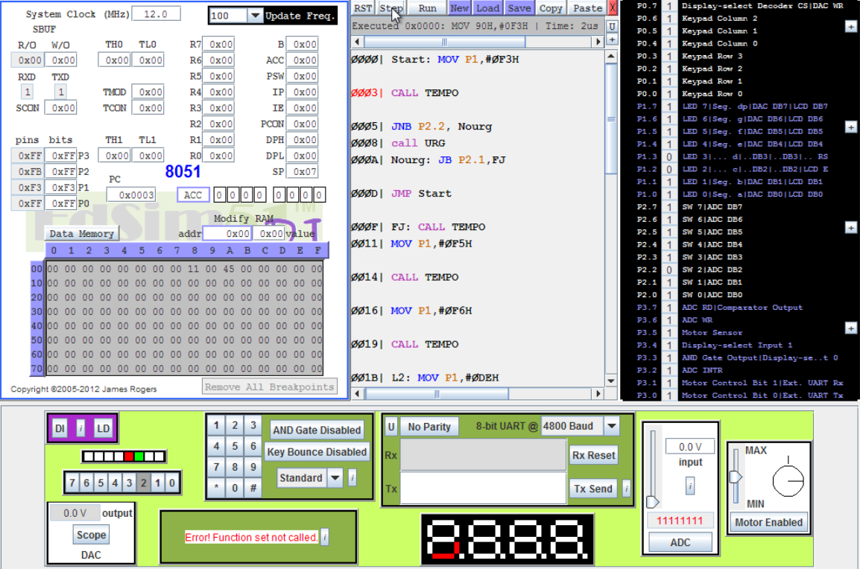

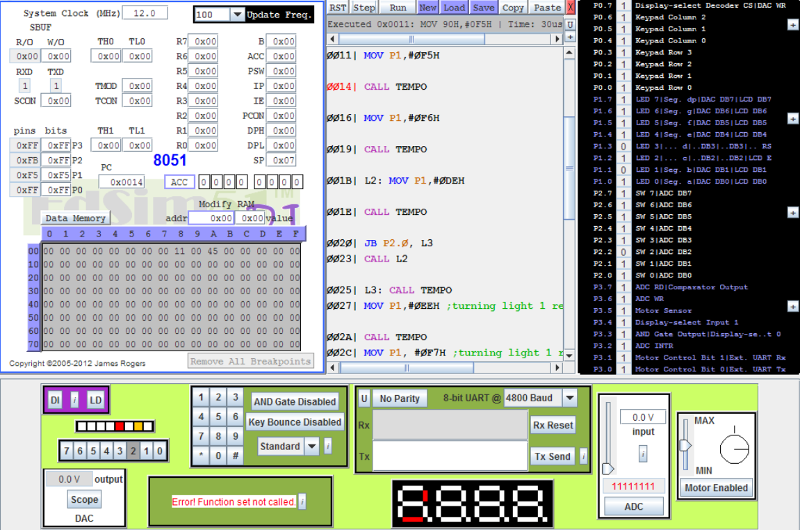

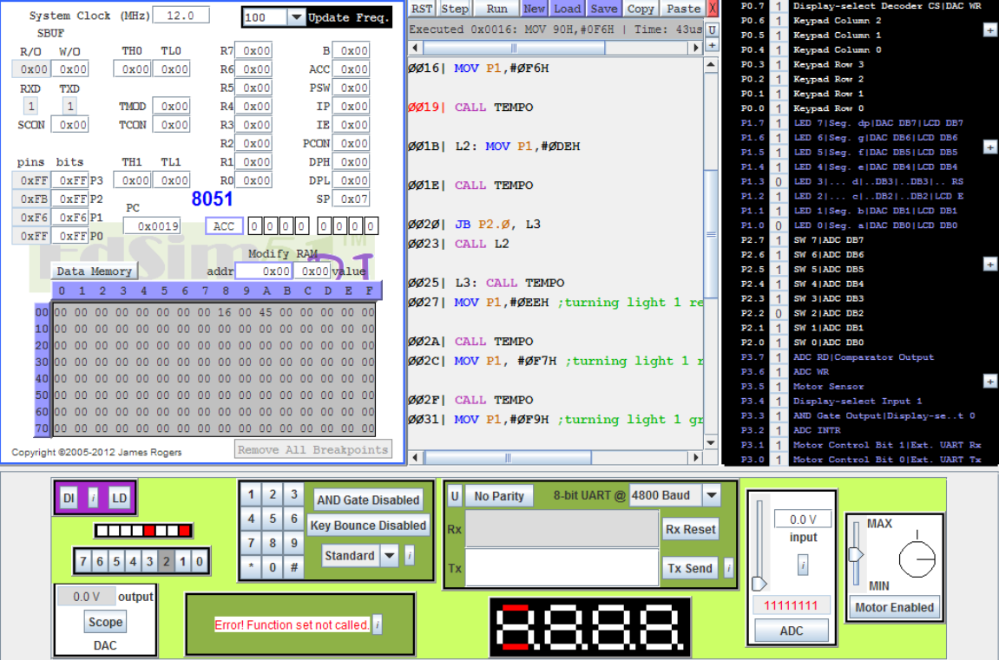

P2.0=1:

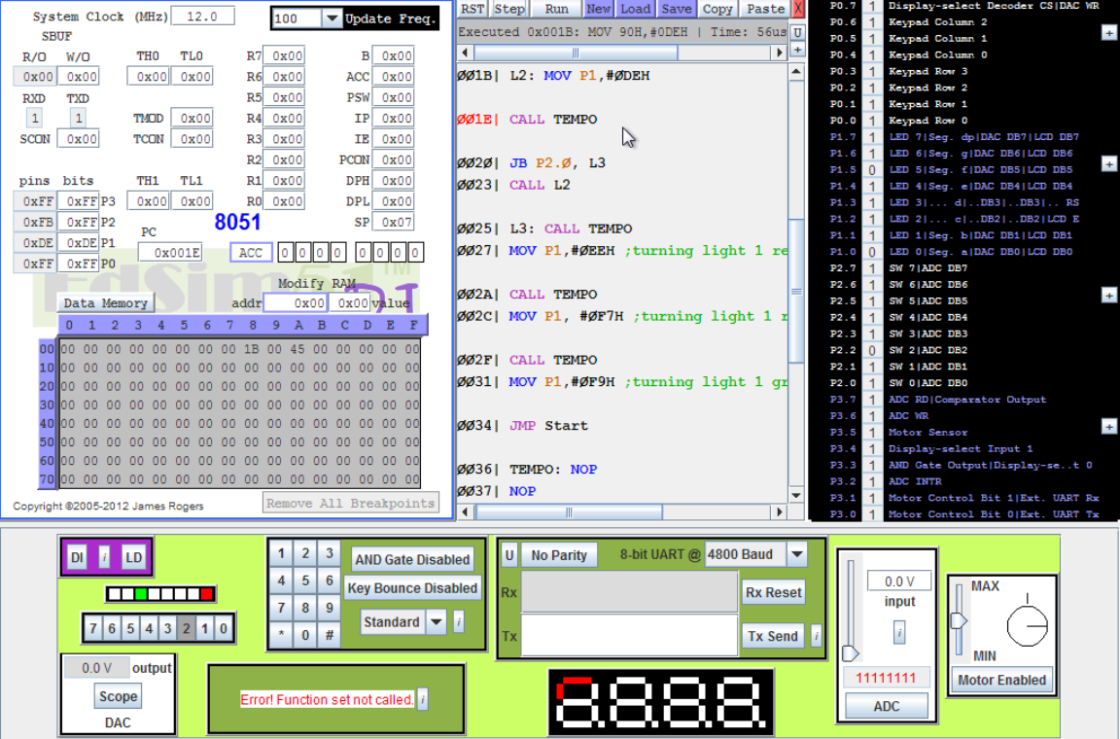

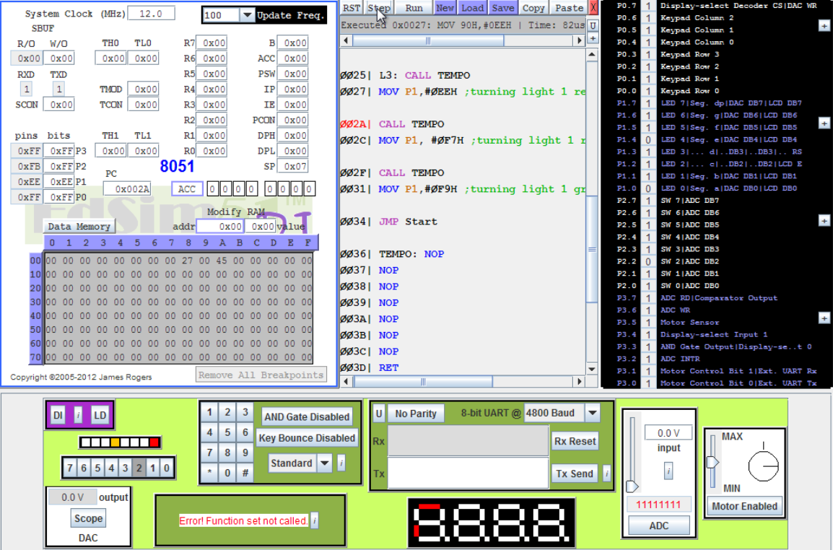

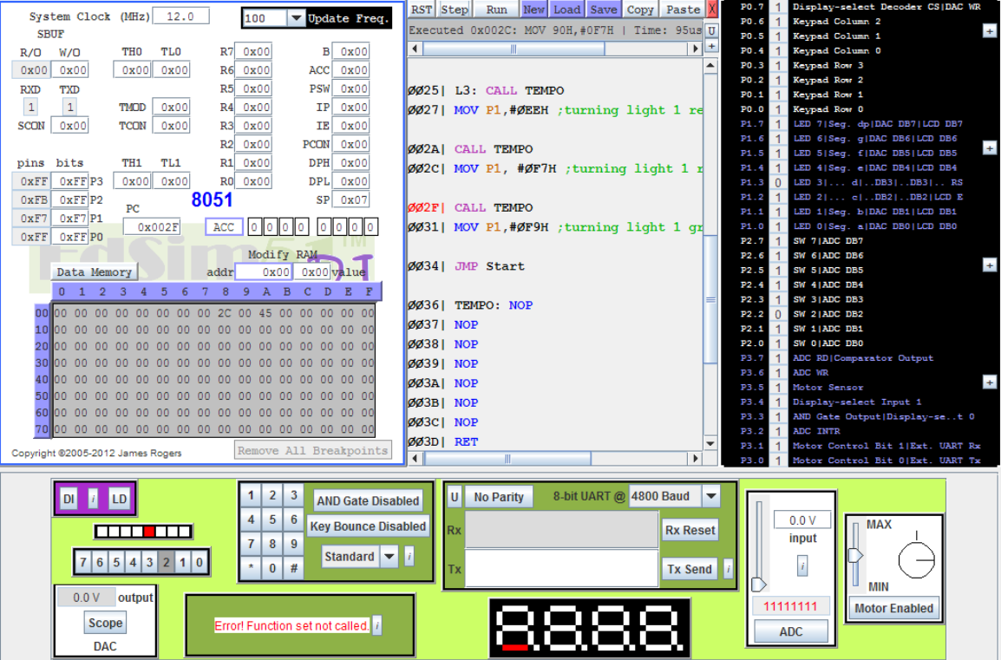

P2.2=1:

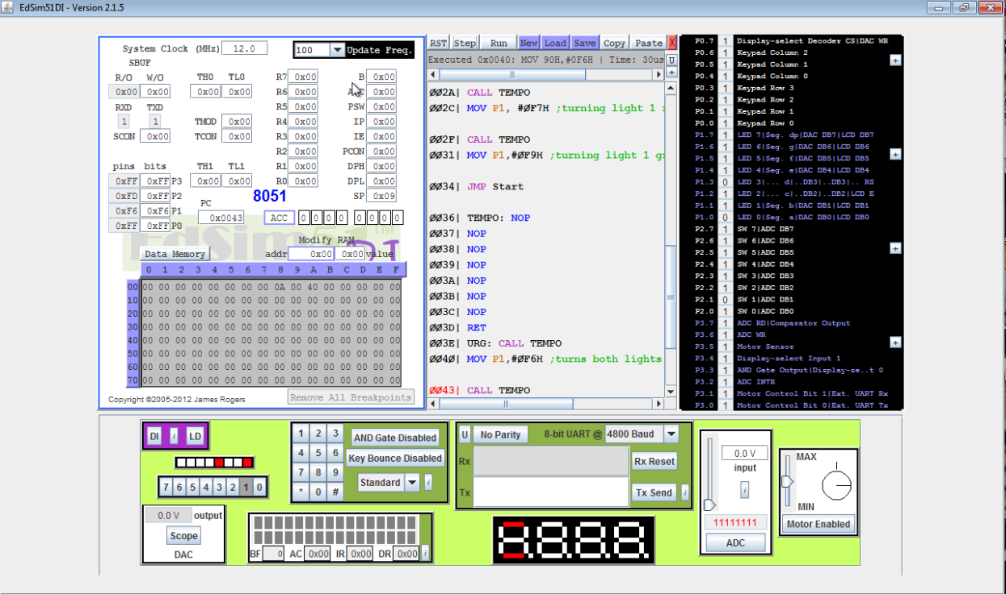

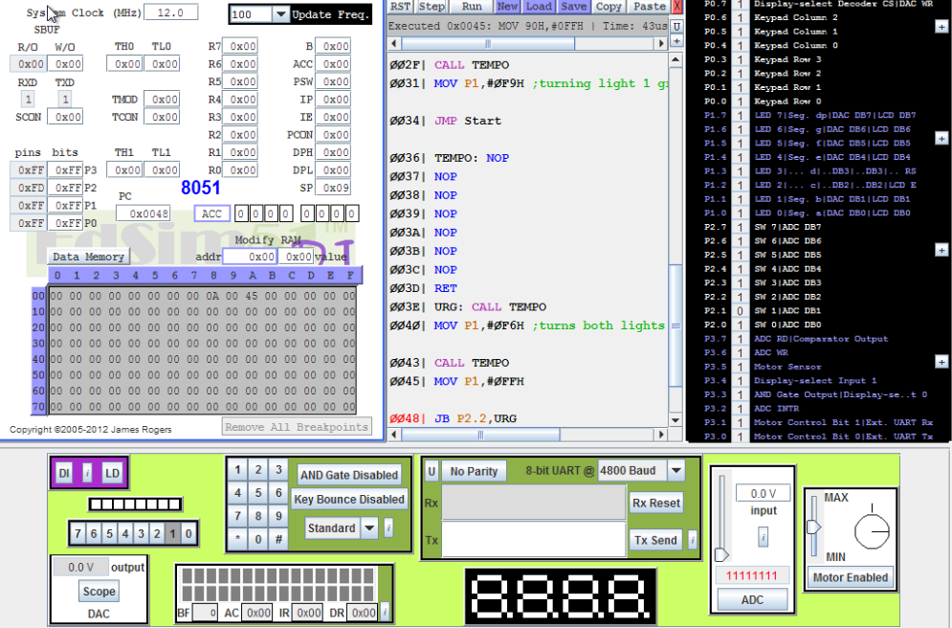

Conclusion:
This lab taught the importance of subroutines and calls, and how using them can greatly reduce the amount of coding necessary. There are many functions that will be have to be called constantly, in this case almost every other line, such as the Tempo function. Once there is input information, conditional statements will need to be implemented using the JMP function. For continuously looping functions such as this one, there will need to be jumps back to the start.

Code:

Start: MOV P1,#0F3H ; p1.2=0 and p1.3=0, L1=Green and L2=Red
CALL TEMPO ; Call delay subroutine
JNB P2.2, Nourg ; If 2.2=0, urgent switch not on, jump to Nourg
call URG ; If 2.1=1, urgent switch is on, jump to URG
Nourg: JB P2.1,FJ ; If P2.1=1, jump to FJ to change Light 1 to Yellow
JMP Start ; Jump back to start to keep light 1 Green and Light 2 Red

FJ: CALL TEMPO
MOV P1,#0F5H ; Set P1.1=0, P1.3=0, Light 1 is Yellow, Light2 is Red
CALL TEMPO
MOV P1,#0F6H ; Set P1.0=0, P1.3=0, Light 1 is Red, Light 2 is red
CALL TEMPO

L2: MOV P1,#0DEH ; Set P1.0=0, P1.3=0, Light 1 = Red, Light 2 = Green
CALL TEMPO
JB P2.0, L3 ; Jump to next step if P2.0 = 1, if 0 keep Light 1 Red and Light 2 Green
CALL L2

L3: CALL TEMPO
MOV P1,#0EEH ; P1.0=0, P1.4=0, Light 1 = Red and Light 2 = Yellow
CALL TEMPO
MOV P1, #0F7H ; P1.0=0, P1.3=0, Light 1 = Red and Light 2 = Red
CALL TEMPO
MOV P1,#0F9H ; P1.2=0, P1.3=0, Light 1 = Green and Light 2 = Red
JMP Start ; Go back to beginning of cycle

TEMPO: NOP ; Time delay routine
NOP
NOP
NOP
NOP
NOP
NOP
RET
URG: CALL TEMPO
MOV P1,#0F6H ;P1.0=0, P1.3=0, Turns both lights red
CALL TEMPO
MOV P1,#0FFH ; All bits set to 1, Turns both lights off
JB P2.2,URG ; Jump back to beginning if P2.2 is still set
RET ; If P2.2 is no longer set, return to previous line
End

