20a)
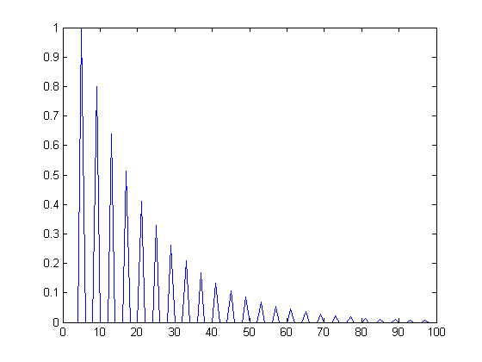
x = zeros(100);
x(1) = 1;
num = [0,0,0,0,1];
den = [1,0,0,0,-.8];
h=filter(num,den,x);
plot(h,'DisplayName','h','YDataSource','h');figure(gcf)

b)
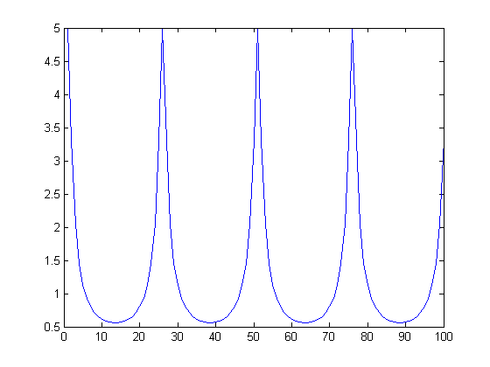

hfft = fft(h);
hm = abs(hfft);
plot(hm,'DisplayName','hm','YDataSource','hm');figure(gcf)

c)
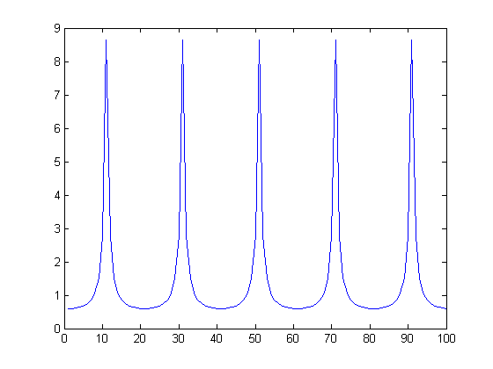

num=zeros(1,6)
num(6)=1;
>> den=zeros(1,6);
>> den(1)=1;
>> den(6)=.9;
h=filter(num,den,x);
>> plot(h,'DisplayName','h','YDataSource','h');figure(gcf)

>> hfft=fft(h);
>> hm=abs(hfft);
>> plot(hm,'DisplayName','hm','YDataSource','hm');figure(gcf)

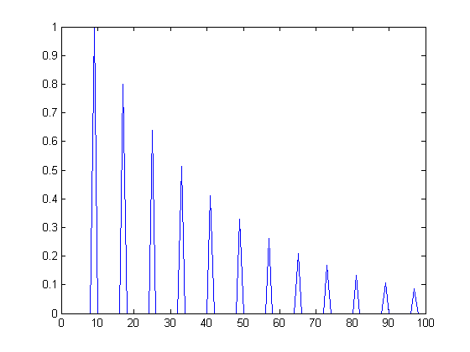

>> num=zeros(1,9);
>> num(9)=1;
>> den=zeros(1,9);
>> den(1)=1;
>> den(9)=-.8;
>> h=filter(num,den,x);
>> plot(h,'DisplayName','h','YDataSource','h');figure(gcf)

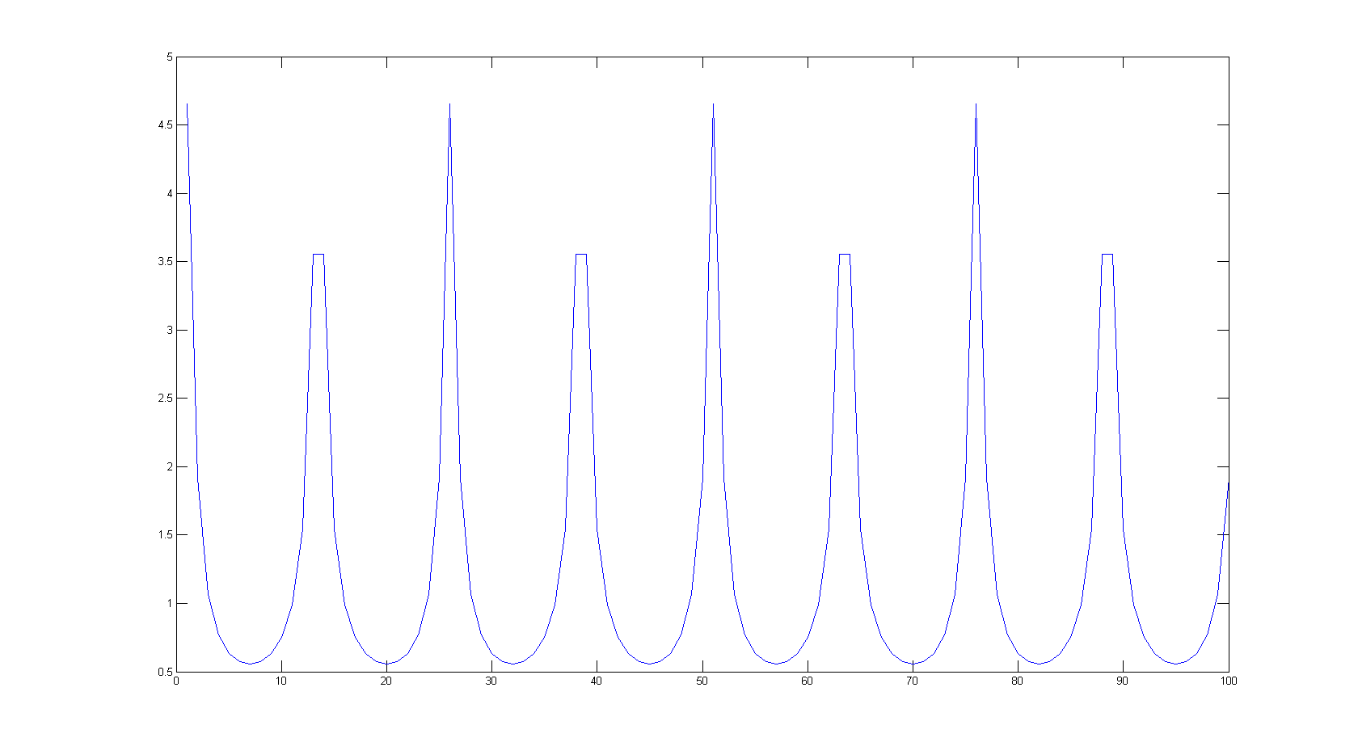

>> hfft=fft(h);
>> hm=abs(hfft);
>> plot(hm,'DisplayName','hm','YDataSource','hm');figure(gcf)

42)
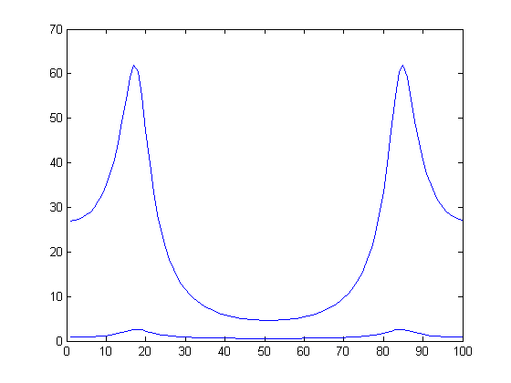
H(Z)mp and H(Z)nmp are a scalar off from each other.

>> c=[1,5.6569,16];
>> roots(c);
>> a = roots(c);
>> a1=1/a(1);
>> a2=1/a(2);
>> num = [1,a2+a1,a1*a2];
>> den = [1,-.8,.64];
>> hnmp = filter(c,den,x);
>> hmp = filter(num,den,x);
>> fftnmp = fft(hnmp);
>> fftmp = fft(hmp);
>> mnmp = abs(fftnmp);
>> mmp = abs(fftmp);
>> plot(mmp,'DisplayName','mmp','YDataSource','mmp');figure(gcf)
>> hold
>> plot(mnmp,'DisplayName','mnmp','YDataSource','mnmp');figure(gcf)

45)
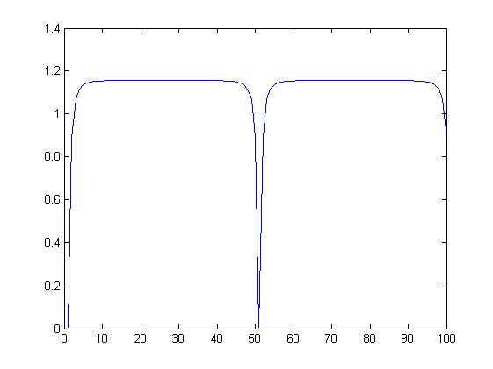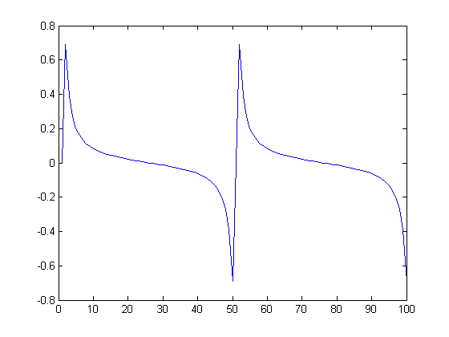
>> num = [1.1,0,-1.1];
>> den = [1,0,-.9];
>> h=filter(num,den,x);
>> hfft=fft(h);
>> mfft= abs(hfft);
>> pfft=angle(hfft);
>> plot(pfft,'DisplayName','pfft','YDataSource','pfft');figure(gcf)
>> plot(mfft,'DisplayName','mfft','YDataSource','mfft');figure(gcf)

c)
function [ y ] = plotfunc( x )

num = [1.1,0,-1.1];
den = [1,0,-.9];
y = filter(num,den,x);

d = zeros(1,8);
d(1) = 1;
h = filter(num,den,x);
Htf = fft(h);
Hm = abs(Htf);

w = 0:pi/8:pi;

subplot(1,2,1);
plot(x);
hold on;
plot(y);
hold off
subplot(1,2,2);
plot(Hm);

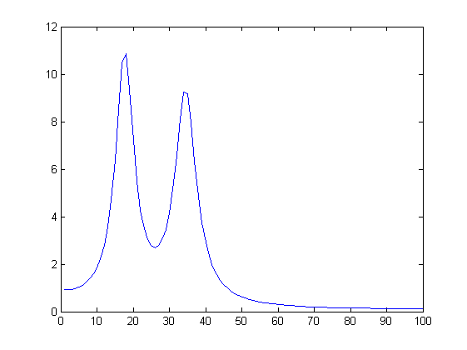

>> num = [1,-2.73,3.73,-2.73,1];
>> den = [1,-2.46,3.02,-1.99,0.66];
>> Gd = grpdelay(num,den,100);
>> plot(Gd,'DisplayName','Gd','YDataSource','Gd');figure(gcf)

