3.22
a)
>> b=[1,1];
>> a=[1,1/4,-1/8];
>> zplane(b,a);
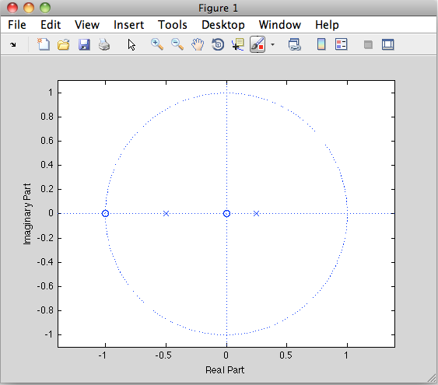

b)
x=[1 0 0 0 0 0 0 0 0 0 0 0 0 0 0 0 0 0 0];
>> y=filter(b,a,x);
>> stem(y);
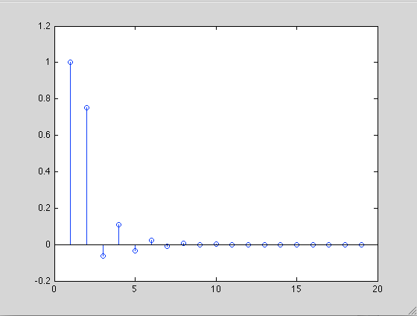

[h,t] = impz(b,a);
>> stem(h);

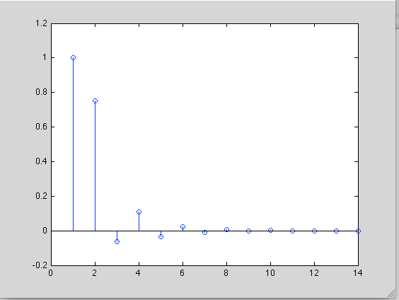

c)
>> [r,p,k] = residuez(b,a);
>> r

r =

-0.6667
1.6667

>> p

p =

-0.5000
0.2500

>> k

k =

[ ]

6.43

function [ xhat,t] = DAC1( x,N,T )

for t = 0:N*T
for n = 0:N
xhat = x*(sin(pi*(t-n*T))/T)/(pi*(t-N*T)/T);
end
end

end

