Comparing Hand Calculated and Simulated RT 60 Times of a Room
MMI 361
Connor McCullough
Spring 2013

Calculations:

The Eyring-Norris equation (given below) was used to predict the RT60 of an apartment bedroom.

RT60 = 0.049V/-S ln(1-alphaaverage)

Alpha average is found by summing all the absorption coefficients of the materials used in the room and weighing them based on the surface area they are used on. The apartment room used for the calculation had walls and a ceiling made out plaster and a concrete floor covered with carpet. Specifically, the NRC was used for the calculations so absorption is more accurate for mid range frequencies. Using this strategy, the RT60 was calculated to be 0.915 seconds. This equation does not take into account the absorption of other materials in the room such as beds or other furniture.

Simulation:

The second phase of the project was to calculate the RT60 by designing the room in Google Sketchup, and then import the design to JBL Ease and simulate the RT60 of the room. For this, the exact dimensions of the walls, ceiling, and floor were needed.

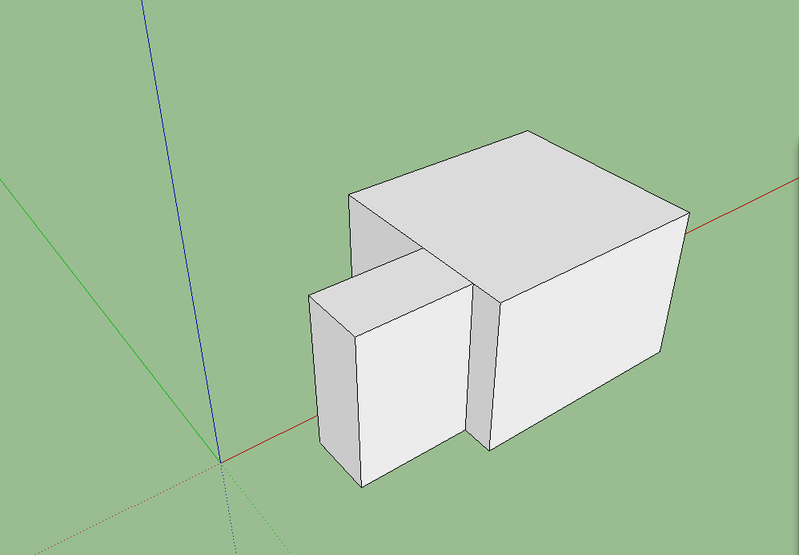

Once the project was created in Sketchup, it was imported to Ease using the Import/Export tool.

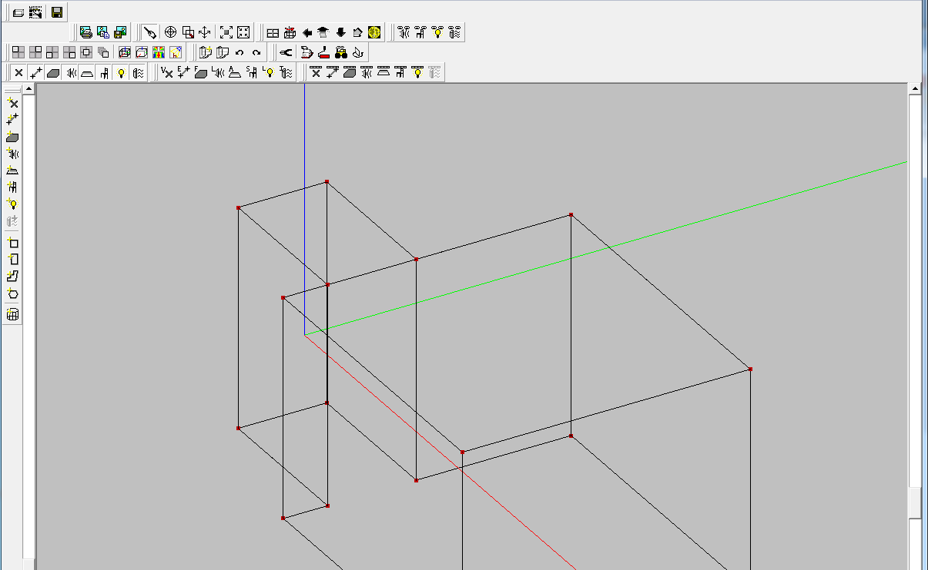

Once in Ease, the individual surface types were changed to drywall and carpet. The Reverb Time window was then brought up with the following results:

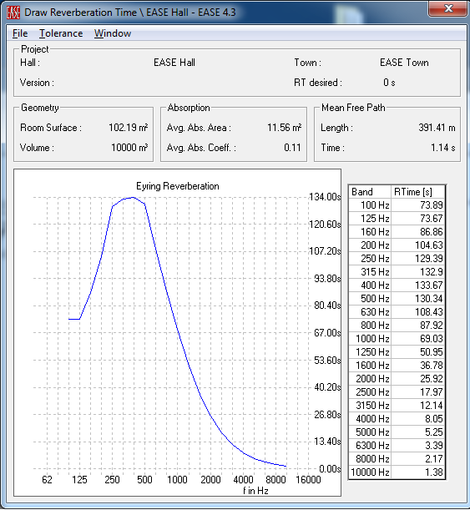

The overall reverb time is only 0.2 seconds away from the calculated reverb time. However, the bands with 130 second reverb times are obviously inaccurate. After debugging, it appears that the JBL file accurately represents the room. My hypothesis is that the RT60 is calculated for discrete frequency amounts that simulate very small frequency bands. Some of these discrete frequency values may cause time values to approach infinity due to the amount of math going on to simulate the room. In the real world, values are continuous and and so you could never have a singular spike in reverb time like you would in a simulation. The program probably fails to average out these values correctly and they disproportionately weigh the value for the entire band.

However, both of these values will be inaccurate from the actual real life value. This is because there are lots of factors that aren’t taken into account such as temperature, humidity, other furniture and materials in the rooms, textural imperfection, and the position in the room that the reverb time is being calculated from.

