Description:
The circuit that was designed was a 16 bit calculator, which had two 16 bit inputs for the two numbers, and a 5 bit operation code parameter. The output was 16 bit as well. This was done using an algorithmic method which was implemented sequentially instead of concurrently. An std_logic_vector was used which allowed both logic and arithmetic functions to be performed. This method made sense for this project because it allowed if statements to be written based on the Opcode.
VHDL Code:
library ieee;
use ieee.std_logic_1164.all;
use ieee.std_logic_unsigned.all;
entity CALC is
port(X,Y: in std_logic_vector (15 downto 0);
OPC: in std_logic_vector (4 downto 0);
OUTPUT: out std_logic_vector (15 downto 0));
end CALC;

architecture BEHAV_CALC of CALC is
begin
CALC_PROCESS: process (OPC,X,Y)
begin
if (OPC="10000")then
OUTPUT <= Y;
elsif (OPC="10001") then
OUTPUT <= Y+'1';
elsif (OPC="10011") then
OUTPUT <= X+Y;
elsif (OPC="10100") then
OUTPUT <= NOT Y;
elsif (OPC="10101") then
OUTPUT <= 0-Y;
elsif (OPC="10111") then
OUTPUT <= Y-X;
elsif (OPC="11000") then
OUTPUT <= Y-'1';
elsif (OPC="11001") then
OUTPUT <= X-Y;
elsif (OPC="11011") then
OUTPUT <= NOT X;
elsif (OPC="11100") then
OUTPUT <= X AND Y;
elsif (OPC="11101") then
OUTPUT <= X OR Y;
elsif (OPC="11110") then
OUTPUT <= X XOR Y;
end if;
end process;
end BEHAV_CALC;
Simulation:
The first simulation uses the opcode 10000 which corresponds to outputting the input Y. It can be seen that “ouput” and “y” are the same.
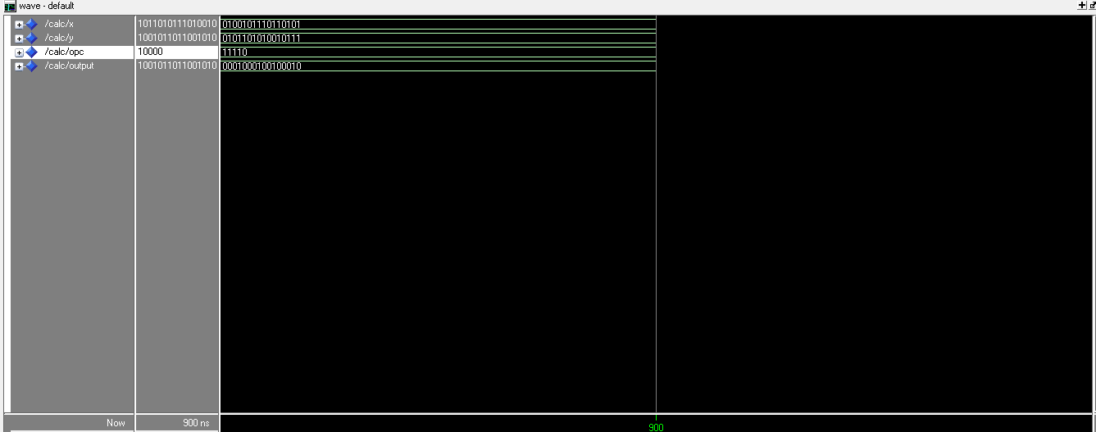
The second simulation uses the opcode 11110 which performs X XOR Y. x = 18868 y = 23191 in decimal “18868 XOR 23191” was input in wolfram alpha and returned 4899, which corresponds to the output in binary.
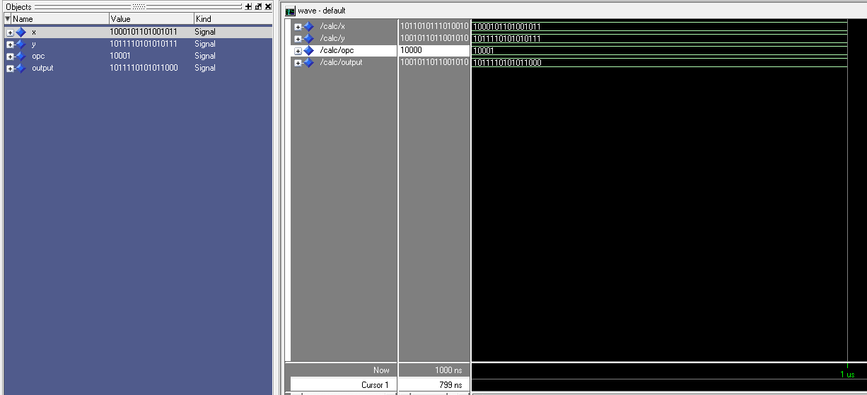
The last simulation uses the opcode 10001 which is Y+1. It can be seen between Y and output that only the 4 least significant bits are changed from the input to output. The change is from “0111” to “1000” which Is the same as adding 1.
Do-script:
force -freeze sim:/calc/x 1011010111010010
force -freeze sim:/calc/y 1001011011001010
force -freeze sim:/calc/opc 10000
run
force -freeze sim:/calc/x 0100101110110101
force -freeze sim:/calc/y 0101101010010111
force -freeze sim:/calc/opc 11110
run
force -freeze sim:/calc/x 1000101101001011
force -freeze sim:/calc/y 1011110101010111
force -freeze sim:/calc/opc 10001
run
force -freeze sim:/calc/x 1000101110101001
force -freeze sim:/calc/y 0010110101101011
force -freeze sim:/calc/opc 10101
run

